BOTSWANA’S CBM INVESTMENT LANDSCAPE

Executive Summary
Botswana’s coal-bed methane (CBM) sector remains pre-commercial but has advanced materially since 2024–2025. The dominant near-term project is Botala Energy’s Serowe CBM Project in central Botswana. In September 2026 the company reported early continuous gas flow at the Pitse Pilot well Serowe-3.5B, with production beginning significantly earlier in the dewatering process than expected (Botala Energy, 2026a). The project holds a mining licence, environmental approvals, a binding letter of intent for LNG offtake with South Africa’s Scaw Metals for up to 3.5–4.7 petajoules (PJ) per year, and a non-binding government equity commitment of approximately BWP 35 million (≈ A$4 million / US$3.6–4 million) via the Minerals Development Company Botswana (MDCB) for a 15% project stake plus a 1% LNG royalty (Botala Energy, 2025a; Sunday Standard, 2025).
Botala targets a final investment decision (FID) in the second half of 2026 and first LNG production around end-2026 or 2027. Tlou Energy’s Lesedi gas-to-power project remains the other principal development, supported by certified reserves and resources, a 10 MW Power Purchase Agreement (PPA) with the Botswana Power Corporation (BPC), and grid-connection infrastructure (Tlou Energy, n.d.). Kalahari Energy continues to hold licences but publishes limited current operational detail.
On a basin scale, the U.S. Geological Survey estimated a mean of 4.5 trillion cubic feet (Tcf) of undiscovered, technically recoverable coalbed gas across the Kalahari Basin Province (Botswana, Zambia and Zimbabwe) (U.S. Geological Survey, 2017). Company figures for specific acreage are higher on a prospective basis: Botala reports 2C contingent resources of 454 billion cubic feet (Bcf) and prospective resources of approximately 7.1 Tcf (best estimate) following a 2024 Sproule recertification (Botala Energy, 2024). Tlou reports 2P reserves of 40.8 Bcf, 3P reserves of 426.6 Bcf and 2C contingent resources of 214 Bcf (Tlou Energy, n.d.).
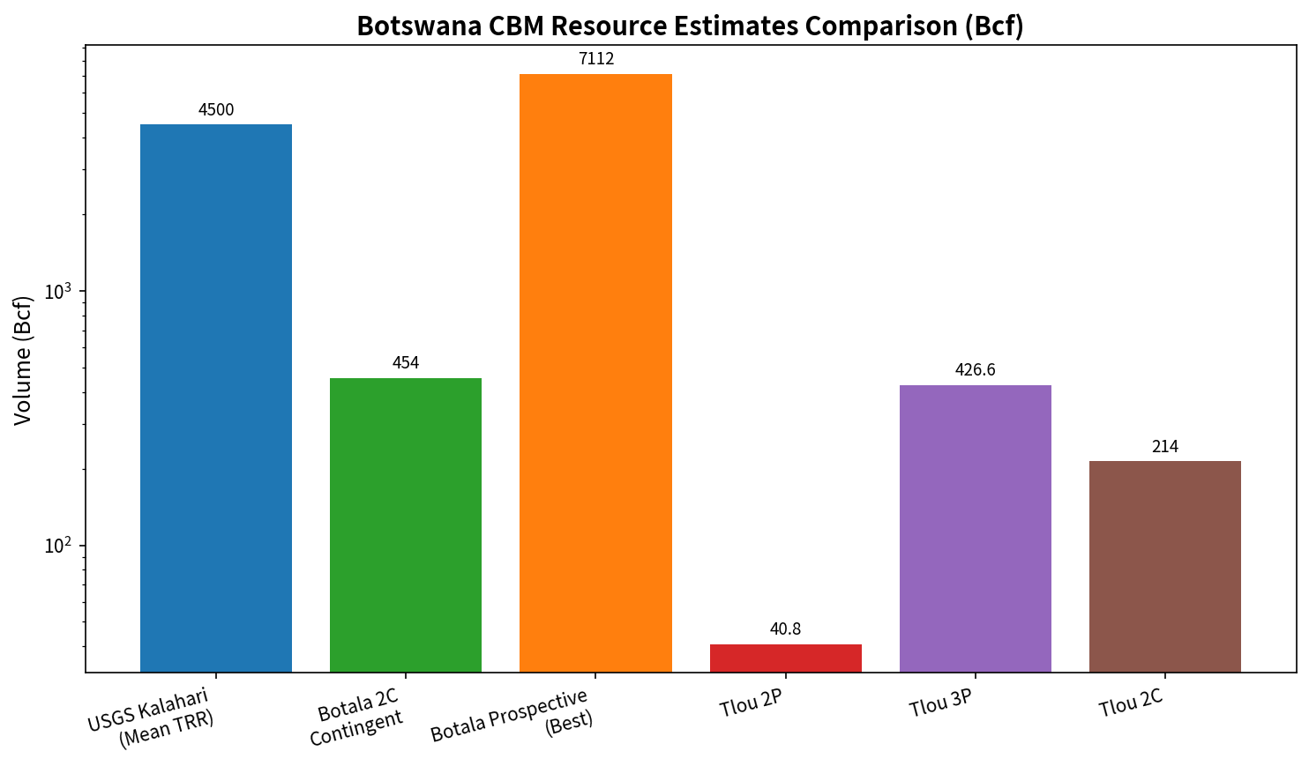
Figure 1. Selected Botswana CBM resource estimates (Bcf, logarithmic scale). Sources: USGS (2017); Botala Energy (2024);
Key trends include growing state equity participation, modular LNG and gas-to-power pathways designed to address domestic power deficits and Southern Africa’s emerging gas shortfall, and regulatory clarification of CBM under the amended Mines and Minerals Act. Constraints remain high capital intensity, limited pipeline and processing infrastructure, offtake certainty beyond initial agreements, and the requirement to convert contingent resources into reserves via sustained commercial flow rates.
The most significant near-term intelligence indicators are Botala’s extended flow-test results and independent resource-to-reserve conversion, FID and financing close, progress on any BPC CBM pilot tenders, and Tlou first-generation milestones.

Introduction
Coal-bed methane is natural gas adsorbed within coal seams and liberated by reducing reservoir pressure, primarily through dewatering. In Botswana, CBM offers a domestic, relatively lower-carbon alternative to imported liquid fuels and electricity, with potential applications in power generation, mining, industry and modular LNG or compressed natural gas (CNG) supply into the Southern African market (Botala Energy, 2026a).
This intelligence note assesses Botswana’s CBM investment environment as of September 2026. It covers resource potential, the evolution of the sector, current investment activity, major projects, key companies, the regulatory and fiscal framework, infrastructure requirements, domestic and regional markets, financing conditions, risks and emerging opportunities. The note distinguishes confirmed activity, announced plans and contingent proposals. Methodology prioritizes primary sources company regulatory announcements (ASX/BSE), government statements, legislative texts and official assessments supplemented by specialized energy reporting. Company forward-looking statements are identified as targets rather than established facts. Where reliable data are unavailable, this is stated explicitly.

Botswana’s CBM Resource Base
The principal CBM-bearing geology occurs within the Karoo Supergroup coals of the Kalahari Basin, particularly the Serowe and Morupule seams and related intervals. The U.S. Geological Survey (2017) applied a geology-based assessment methodology and estimated a mean of 4.5 Tcf of undiscovered, technically recoverable coalbed gas for the Kalahari Basin Province (Botswana–Zambia–Zimbabwe), with an F95–F5 range of approximately 0.6–11.7 Tcf.
Company-reported volumes for specific license areas are higher on a prospective basis but remain largely contingent or prospective:
- Botala Serowe (Sproule recertification, July 2024): 2C contingent resources 454 Bcf (up 42% from 317 Bcf); prospective resources best estimate ≈ 7.1 Tcf (Botala Energy, 2024).
- Tlou Energy: 2P reserves 40.8 Bcf, 3P reserves 426.6 Bcf, 2C contingent resources 214 Bcf (Tlou Energy, n.d.).
- Historical operator estimates (e.g., Magnum/Kalahari-related) have cited multi-Tcf gas-in-place figures that have not been independently converted to commercial reserves at scale.
Reliability is moderate for contingent resources, which are supported by core, desorption and limited flow data, but lower for prospective volumes that require further delineation and demonstration of commercial flow rates. Geological and technical factors include moderate gas content, variable permeability (stimulation is frequently required), and the necessity of sustained dewatering. In the Serowe area, key seams occur at relatively shallow depths of approximately 300–400 m, which can reduce development costs relative to deeper basins (Botala Energy, 2026a).

Table 1. Major CBM Areas and Selected Resource Estimates
Area / Operator | Category | Volume | Date / Source | Notes
Kalahari Basin Province | Undiscovered TRR (mean) | 4.5 Tcf | USGS 2017 | Botswana + Zambia + Zimbabwe
Botala Serowe | 2C Contingent | 454 Bcf | Sproule Jul 2024 | Best estimate; prior 317 Bcf
Botala Serowe | Prospective (best) | ~7.1 Tcf | Company / Sproule | Unrisked
Tlou Lesedi / related | 2P / 3P / 2C | 40.8 / 426.6 / 214 Bcf | Company public figures | Certified reserves exist

Evolution of Botswana’s CBM Sector
Exploration activity began in the 2000s and early 2010s with multiple junior companies. Early pilot work by Tlou Energy and Kalahari Energy produced limited gas flows and conceptual power-generation schemes. Progress largely stagnated amid low gas prices, infrastructure gaps and financing constraints until the mid-2020s.
Important turning points include Tlou’s execution of a pilot and subsequent 10 MW PPA with BPC together with grid-connection works; Botala’s successive resource upgrades, award of a mining license in March 2025, environmental approvals, the Scaw Metals offtake letter of intent (March 2025), and MDCB equity discussions in 2025; and the 2024 amendment of the Mines and Minerals Act that explicitly recognized coal-bed methane licenses (Botswana Government, 2024; Botala Energy, 2025b). The sector has shifted from pure exploration toward pilot production and modular commercialization pathways (gas-to-power and mini-LNG).

Current Investment Landscape
Investment activity is concentrated in two Australian-listed juniors with Botswana subsidiaries, supplemented by state participation via MDCB. Botala has attracted the clearest recent capital commitment in the form of the non-binding MDCB term sheet for approximately A$4 million of project-level equity plus a royalty (Botala Energy, 2025a). Private equity and strategic off taker interest is emerging around modular LNG. Total committed capital remains modest relative to full-field development requirements; most expenditure to date has been directed at exploration, appraisal and pilot drilling, funded by equity raises and proposed government co-investment.

Major CBM Projects and Project Pipeline

Serowe CBM Project (Botala Energy)
Location: Central Botswana (Serowe area). Licence: Mining Licence ML-52 awarded March 2025, together with additional prospecting licences. Operator/ownership: Botala Gas (Pty) Ltd (100% Botala Energy prior to MDCB close); non-binding term sheet for MDCB 15% equity plus 1% LNG royalty. Resources: 2C 454 Bcf; prospective ≈ 7.1 Tcf (best estimate).
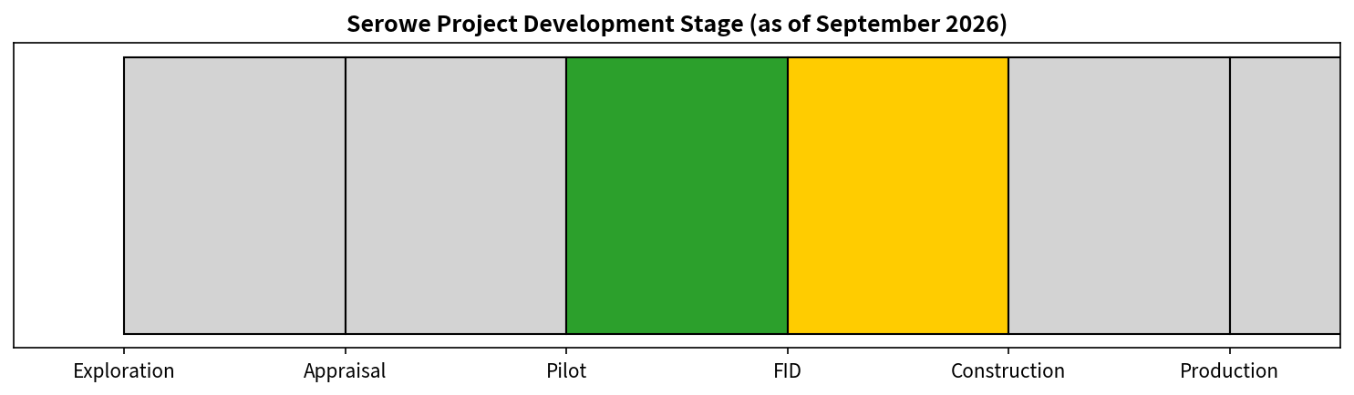
Figure 2. Serowe project development stage as of September 2026.
Status (September 2026): The Pitse Pilot central production well Serowe-3.5B achieved continuous and steadily increasing gas flow, with the first continuous flare recorded on 20–21 September 2026 while the water level remained approximately 60 m above the coal seam—earlier than the company’s prior expectation (Botala Energy, 2026a). The project is categorised as pilot / pre-FID development. Planned capacity is phased: initial mini-LNG (Galileo-type units) targeting 3.5 PJ/year from approximately 108 wells at full scale. Offtake: binding letter of intent with Scaw Metals for up to 3.5 PJ/year LNG (option to 4.7 PJ); first supply targeted 2027–2028. Additional industrial interest has been reported (e.g., discussions linked to Kemcore). Investment: government ≈ BWP 35 million proposed; full development capital is multi-tens of millions of US dollars on a phased basis. FID is targeted for H2 2026 (Botala Energy, 2025a; Energies Media, 2026).
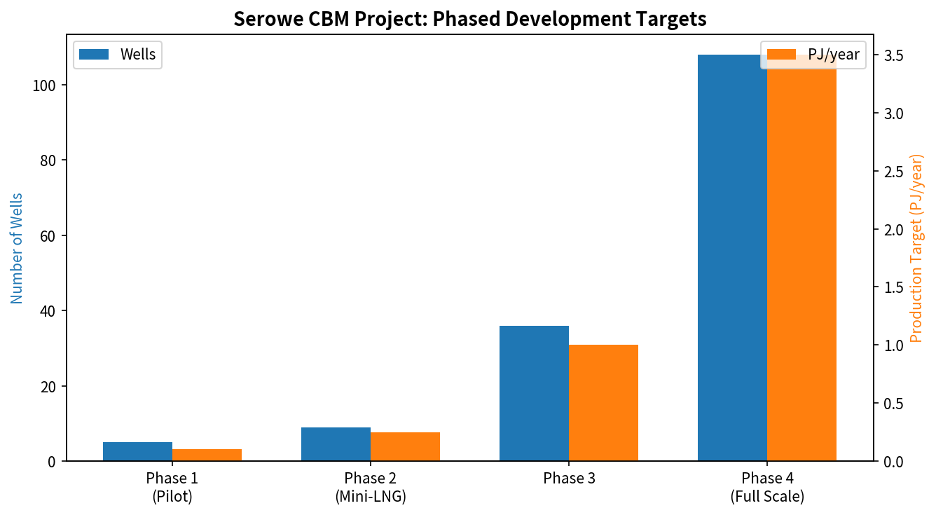
Figure 3. Serowe CBM project phased development targets (wells and indicative PJ/year).
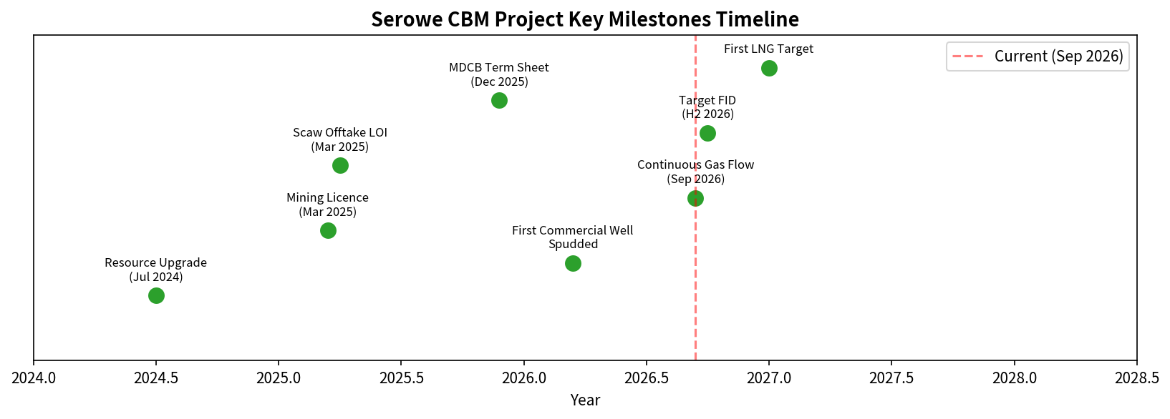
Figure 4. Selected Serowe CBM project milestones timeline.
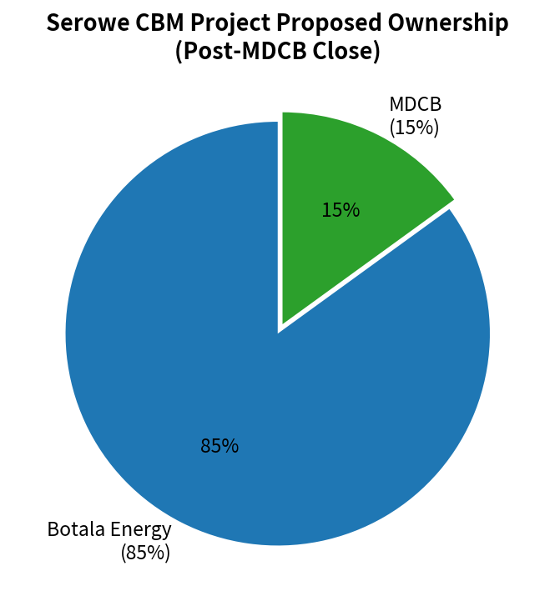
Figure 5. Proposed Serowe project ownership following MDCB close (non-binding term sheet).

Lesedi Power Project (Tlou Energy)
Location: Central District. Licences: mining licence valid until 2042 and extensive prospecting acreage (approximately 8,000 km² plus 800 km² production). Ownership: Tlou 100%. Resources: 2P 40.8 Bcf, 3P 426.6 Bcf, 2C 214 Bcf. Status: gas field developed; 10 MW gas-to-power under PPA with BPC; 66 kV grid connection advanced; expansion toward 25 MW and potentially 100 MW planned. Alternative offtake concepts (data centres) have been discussed. Categorised as development / near-production (Tlou Energy, n.d.).

Other Activity
Kalahari Energy holds licences and has historically pursued gas-to-power concepts; current public operational detail is limited. The Botswana Power Corporation has issued tenders for the design, installation, commissioning and operation of 10 MW CBM pilot plants as independent power producers (Botswana Power Corporation, 2026).

Table 3. Botswana CBM Project Pipeline Summary (September 2026)
Project | Operator | Focus | Status | Key Near-Term
Serowe | Botala Energy | CBM-to-LNG | Pilot / pre-FID | FID H2 2026
Lesedi | Tlou Energy | Gas-to-power | Development | First generation
BPC CBM Pilots | Tender / IPPs | Power (10 MW) | Tender stage | Award process

Key Companies and Investors

Botala Energy (ASX/BSE: BTE)
Australian-listed, Botswana-focused CBM-to-LNG developer. Holds 100% of Serowe via subsidiary prior to MDCB close. Strategy centres on modular LNG for industrial offtake and a potential power/industrial hub at Leupane. Recent milestones include the 2024 resource upgrade, mining licence, offtake LOI, government term sheet and early continuous flow at well 3.5B (Botala Energy, 2024, 2025a, 2026a).

Tlou Energy (ASX/BSE)
Longer-established CBM-to-power developer. Lesedi is the flagship asset with certified reserves and a PPA. The company is exploring power expansion and alternative offtake including data centres (Tlou Energy, n.d.).

Minerals Development Company Botswana (MDCB)
State investment vehicle under the Ministry of Minerals and Energy. Proposed 15% equity plus royalty participation in Serowe (Botala Energy, 2025a).

Kalahari Energy
Privately held; historical CBM activity and power-plant ambitions. Limited current public disclosure.
Offtakers and potential partners include Scaw Metals (South African industrial), BPC (power), and emerging industrial users such as Kemcore (battery-chemicals discussions linked to the Leupane concept) (Business Insider Africa, 2026).

Regulatory and Investment Framework
CBM is explicitly recognised under the Mines and Minerals Act as amended by Act 14 of 2024, which provides for coal-bed methane licences distinct from conventional petroleum rights under the Petroleum (Exploration and Production) Act (Botswana Government, 2024). The 2024 amendment also introduced local-ownership provisions requiring the offer of stakes to citizens or government in certain cases. The Botswana Energy Regulatory Authority (BERA) regulates electricity, petroleum and gas activities, including licensing of infrastructure, storage, transport and related operations.
Key agencies include the Ministry of Minerals and Energy, the Department of Mines, MDCB, BPC, BERA and environmental authorities. Fiscal terms follow standard mining and petroleum frameworks (royalties, corporate tax, potential equity participation). Recent reforms have clarified CBM title and encouraged state participation. Regulatory risk is assessed as moderate: licensing processes have delivered mining licences and environmental approvals for Serowe, while broader gas-market regulation and third-party access rules continue to mature.

Infrastructure and Investment Requirements
Critical gaps include limited gas gathering, processing, compression and long-distance pipeline capacity. Serowe development is designed around modular mini-LNG units and trucking or short-haul distribution rather than large trunk pipelines. Power projects require generation plant and grid interconnection (Tlou has advanced 66 kV works). Additional requirements encompass produced-water handling, possible CNG infrastructure, industrial distribution networks and hybrid gas-solar concepts (e.g., Botala’s Leupane Energy Hub). Capital requirements for full commercialisation are significant and are being approached on a phased basis so that early modules can prove concept before larger commitments.
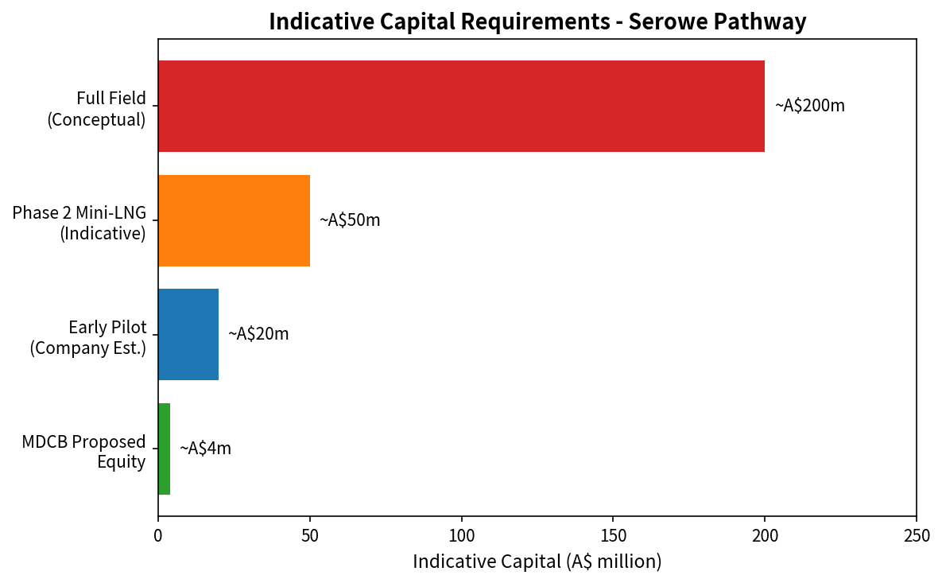
Figure 6. Indicative capital requirements along the Serowe pathway (A$ million; company estimates and conceptual scaling).

Domestic Market and Commercialisation Potential
Botswana’s energy mix remains heavily dependent on coal-fired generation (Morupule), imported electricity and liquid fuels. Power deficits and elevated import costs create demand for domestic gas-fired generation. Mining and emerging industrial users (including potential battery-chemicals processing) are natural anchor customers. CBM can displace diesel and imported power. Commercial viability depends on sustained well deliverability, delivered gas or LNG price competitiveness versus alternatives, and firm offtake. The Scaw LOI and BPC PPAs provide initial anchors; broader industrial demand is emerging but is not yet contracted at scale.

Regional Market and Export Opportunities
Southern Africa faces a projected gas supply shortfall. Modular LNG or CNG can reach South African industrial users without major new pipelines. Longer-term pipeline links into the Southern African Power Pool or regional gas networks remain conceptual and capital-intensive. Near-term opportunity therefore centres on trucked LNG/CNG into South Africa rather than large-scale pipeline export. Constraints include distance, competing supply sources and infrastructure cost.
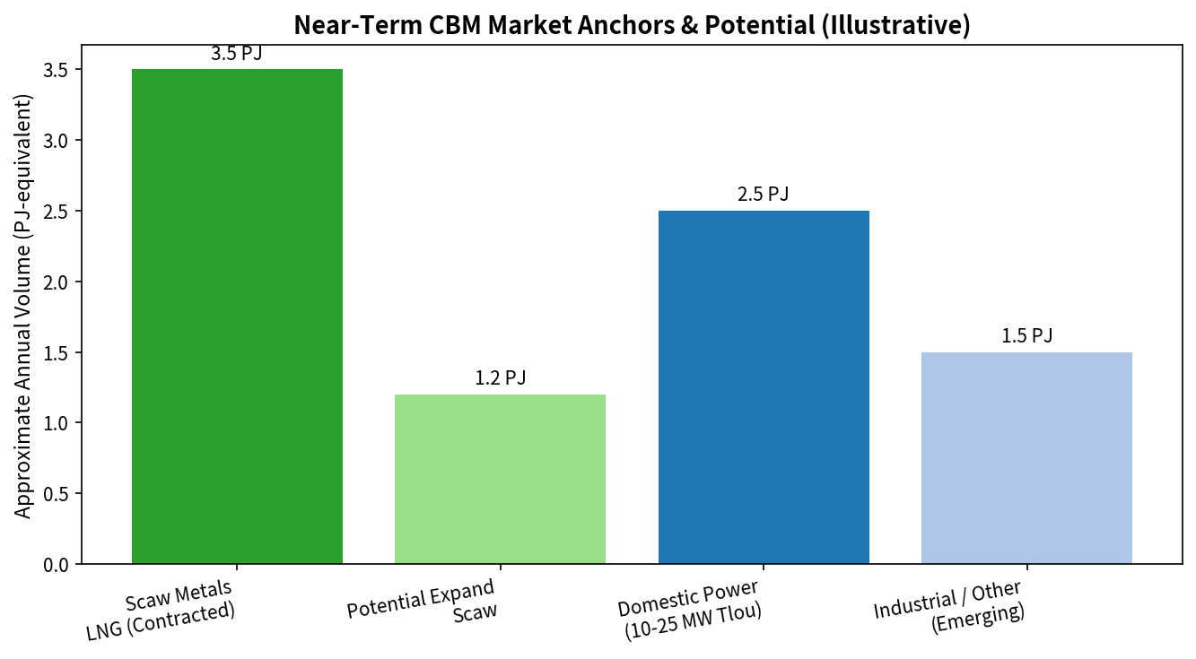
Figure 7. Near-term CBM market anchors and illustrative potential (PJ-equivalent).

Financing and Investment Environment
Funding to date has consisted primarily of equity raised on the ASX and BSE, supplemented by the proposed state equity injection. Development finance institutions, commercial banks and strategic offtakers are potential sources once reserves and cash-flow visibility improve. Key challenges include resource-to-reserve conversion risk, infrastructure funding requirements, offtake tenor and commodity-price exposure. The MDCB term sheet constitutes a positive signal of government alignment. Full FID financing for Serowe is expected to require a blend of equity, debt and possibly offtaker or vendor financing for modular plant.

Investment Risks and Constraints
Principal risk categories and current assessment:
- Geological and resource risk – Contingent resources require commercial flow rates for reserve booking. Early continuous flow at Serowe-3.5B is encouraging but extended testing is required (Botala Energy, 2026a).
- Technical and operational risk – Dewatering performance, stimulation effectiveness and produced-water management.
- Infrastructure constraints – Limited shared midstream infrastructure; reliance on modular and trucked solutions.
- Market and offtake risk – Dependence on a limited number of initial contracts; competition from coal, solar and imports.
- Financing risk – Junior-developer balance sheets and the need for project-level capital at FID.
- Regulatory risk – Evolving gas-market rules and local-content/ownership provisions (Botswana Government, 2024).
- Commodity-price and regional market risk – Exposure to gas and power price movements and competing regional supply.
- Environmental and social considerations – Water use, land access and residual greenhouse-gas intensity.
Demonstrated risks currently centre on the pilot-to-commercial conversion step. Many other risks remain contingent on execution outcomes.

Investment Opportunities
Specific areas across the value chain where opportunities may emerge, subject to successful pilot results and offtake:
- Further exploration and appraisal of undrilled acreage (resource upside).
- Gas production and modular processing / mini-LNG facilities.
- Gas-to-power (BPC tenders and private generation).
- Industrial fuel supply and CNG logistics.
- Supporting infrastructure (gathering, compression, water handling).
- Technology and services (stimulation, reservoir monitoring, modular plant).
- Hybrid energy hubs linking CBM with solar and industrial parks.
Each opportunity becomes commercially viable only after demonstration of sustained commercial flow rates, secure offtake and access to development capital.

Outlook and Key Intelligence Indicators
The trajectory is cautiously positive. Early gas flow at Serowe, government co-investment and offtake agreements mark a transition from exploration to pilot commercialization. Commercial production of LNG or power before the end of 2027 is plausible if flow rates are sustained and FID plus financing close in 2026.
Factors that could accelerate development include positive extended flow-test results, timely FID, successful financing, additional offtake contracts and BPC pilot awards. Factors that could delay development include disappointing well performance, financing shortfalls, infrastructure or regulatory bottlenecks, and weaker regional gas prices.
Investors and stakeholders should monitor: Botala’s 90-day extended flow-test results and any independent resource-to-reserve upgrades; FID announcement; binding close of the MDCB investment; Tlou first-generation and expansion milestones; any new licensing rounds or BPC CBM IPP awards; further infrastructure or offtake announcements; and implementing regulations for CBM and gas midstream activities.

Conclusion
Botswana possesses a material CBM resource base within the Kalahari Basin. The Serowe and Lesedi projects represent the most advanced commercial pathways. Investment activity has increased through government equity participation, offtake agreements and pilot progress, yet the sector remains capital- and data-constrained. Commercial success depends on converting contingent resources into proven reserves via sustained production, securing phased financing, and matching modular gas supply to domestic power and regional industrial demand. The next 12–18 months of flow testing, FID decisions and financing outcomes will determine whether CBM becomes a meaningful contributor to Botswana’s energy security and a viable destination for larger-scale investment.

Key Intelligence Takeaways
- Serowe (Botala Energy) is the lead project: continuous gas flow was confirmed in September 2026; a mining licence, offtake LOI and government equity term sheet are in place; FID is targeted for the second half of 2026 (Botala Energy, 2026a, 2025a).
- Basin-scale resource potential is substantial (USGS mean 4.5 Tcf TRR), but commercially proven reserves remain limited; most volumes are contingent or prospective (U.S. Geological Survey, 2017; Botala Energy, 2024; Tlou Energy, n.d.).
- Government co-investment via MDCB is a material de-risking signal but does not eliminate technical or market risk (Botala Energy, 2025a).
- Near-term commercial models are modular (mini-LNG and gas-to-power) rather than large-pipeline export.
- Primary constraints are infrastructure, reserve conversion and financing scale; primary opportunities lie in pilot success unlocking phased development and industrial offtake.

References
Botala Energy. (2024). 42% increase in CBM resources (ASX announcement, July 2024). https://www.listcorp.com/
Botala Energy. (2025a). MDCB increases investment proposal to A$4 million (ASX announcement, December 2025). https://www.listcorp.com/
Botala Energy. (2025b). Serowe CBM Project mining licence awarded and related updates. Company disclosures.
Botala Energy. (2026a). Botala Energy achieves early continuous gas flow at Serowe’s Pitse pilot well (September 2026). Small Caps / company announcement. https://smallcaps.com.au/
Botswana Government. (2024). Mines and Minerals (Amendment) Act, 2024 (Act No. 14 of 2024). https://botswanalaws.com/
Botswana Power Corporation. (2026). Tender for design, installation, commissioning and operation of 10 MW CBM pilot plants as IPPs (Tender No. 7614/25). https://www.bpc.bw/
Business Insider Africa. (2026, September 16). Botswana approves $140 million plant set to become Southern Africa’s first integrated battery minerals complex. https://africa.businessinsider.com/
Energies Media. (2026). Botswana coal-bed methane development targets 2026 investment decision. https://energiesmedia.com/
Sunday Standard. (2025, December 14). Govt pumps P53 million into private coal bed methane project. https://www.sundaystandard.info/
Tlou Energy. (n.d.). Lesedi Power Project. https://tlouenergy.com/projects/
U.S. Geological Survey. (2017). Assessment of coalbed gas resources of the Kalahari Basin Province, Botswana, Zimbabwe, and Zambia (Fact Sheet 2017-3003). https://pubs.usgs.gov/
Upstream Online. (2025). Botswana CBM project expects FID in 2026. https://www.upstreamonline.com/

.

