SUDAN'S GAS RESOURCES AND THE STRATEGIC COMPETITION FOR THE RED SEA

Executive Summary
Sudan holds an estimated 3 trillion cubic feet (Tcf) of natural gas reserves and a largely unexplored 57,000 km² offshore margin on the western Red Sea, but the country neither produces nor consumes gas in meaningful volumes today. This note assesses whether that resource position combined with Sudan's Red Sea coastline, its ports at Port Sudan and Suakin, and its location at the intersection of Egyptian, Saudi, Gulf and Horn of Africa strategic interests can translate into genuine geopolitical leverage, or whether it instead becomes another arena in which external powers compete for influence over a weak and internally fractured state.
The central finding is that Sudan's gas potential is currently a geological and locational fact, not a strategic asset. No commercial gas production exists; the sole confirmed discoveries (Suakin-1, Bashayer-1) date to the 1970s and were never appraised; and three years of civil war between the Sudanese Armed Forces (SAF) and the Rapid Support Forces (RSF) have devastated the institutional, financial and technical capacity needed to convert acreage into production. China's National Petroleum Corporation (CNPC), Sudan's most experienced hydrocarbons partner for three decades, formally withdrew from its last operating block in late 2025, invoking force majeure a strong signal that even patient, state-backed capital now judges the risk-adjusted return on Sudanese hydrocarbons to be negative.
What is strategically live is not the gas itself but the Red Sea coastline and Port Sudan, which have become objects of intense competition among Egypt, Saudi Arabia, the UAE, Turkey and Russia a competition that runs largely independent of, and well ahead of, any gas development. Russia has secured a naval-base agreement at Port Sudan (February 2025); Turkey is developing a naval-dock project at Suakin; the UAE's earlier port and free-zone ambitions at Abu Amama collapsed in November 2024 amid accusations of RSF backing; and Saudi Arabia has moved from mediation toward deeper institutionalization of its relationship with the SAF-led government, culminating in an August 2026 Saudi-Sudanese Coordination Council and a Saudi-led Red Sea security coalition that Sudan has joined. Gas licenses, port concessions and electricity interconnection (Egypt-Sudan, and the newly operational 3,000 MW Egypt-Saudi HVDC link) are all becoming instruments through which these external actors seek durable footholds, regardless of whether Sudanese gas itself is ever monetized.
The report's judgement is that, absent a durable political settlement, Sudan is best characterized as a strategically vulnerable state whose gas resources primarily provide an additional channel through which external competition is conducted, rather than a strategic asset that Sudan itself can leverage. A change in this trajectory would require, at minimum, an end to active conflict, a unified national authority able to sign and enforce contracts, and a competitive licensing process that diversifies foreign participation rather than concentrating it in the hands of whichever external patron currently backs the dominant faction in Port Sudan.

Key Judgements
- Sudan's proven gas reserves (≈3 Tcf, EIA/industry estimates for 2024) are a fraction of regional peers and remain entirely undeveloped; treat all larger figures as unapprised geological potential, not reserves.
- The Red Sea coastline and Port Sudan carry far greater and more immediate strategic value than the gas itself, evidenced by the Russia naval-base agreement, Turkish naval-dock construction at Suakin, and repeated UAE, Saudi and Turkish port initiatives.
- CNPC's December 2025 withdrawal from Sudan is the single most important recent signal for the gas sector: three decades of Chinese oil diplomacy in Sudan have ended, reducing the pool of investors willing to accept Sudan's risk profile.
- Saudi Arabia has moved decisively closer to the SAF-aligned government in 2025-2026 (Coordination Council, Red Sea security coalition, investment forum pledges), positioning Riyadh as the most consequential external actor for Sudan's coastal and energy future.
- Domestic conflict, not global gas markets, is the binding constraint on Sudan's energy strategy: repeated RSF drone strikes on the Merowe Dam and national grid have cut electricity generation by an estimated 40-60%, a more urgent problem than offshore exploration.
- Sudan's bargaining power is currently minimal; competitive, transparent licensing and diversified foreign participation not exclusive deals with any single patron represent the only credible path to converting geography into leverage.

1. Sudan's Gas Position in the Red Sea Region
As of 2024, Sudan's proven natural gas reserves were estimated at approximately 3 trillion cubic feet (Tcf), alongside 1.25 billion barrels of proven oil reserves, according to U.S. Energy Information Administration-referenced industry data. Critically, Sudan neither produces nor consumes gas in significant quantities the reserve figure describes an in-ground resource, not an active industry. This distinction matters throughout this note: Sudan has geological potential, not commercial production.
The country's confirmed gas discoveries are historic rather than current. Chevron's Bashayer-1 and Suakin-1 wells, drilled in the 1970s off the Red Sea State coast, proved gas and condensate in the Miocene section, but both received poor appraisals and subsequently stalled for decades. Onshore, gas shows have been reported in West Kordofan, East Darfur, the Red Sea state and the Dinder area, but a French firm's mid-2010s effort to quantify these volumes was never followed by public, audited reserve certification — these remain prospective resources at best.
Sudan's offshore Red Sea margin (principally Block 13 and adjacent acreage) covers roughly 57,000 km² between Egyptian and Eritrean waters, yet only about 14 wells have ever been drilled there, mostly using pre-seismic-era technology. A 2022-era 2D seismic rectification and planned 3D acquisition by Searcher Geodata, conducted in cooperation with the Sudan Ministry of Energy and Petroleum, mapped extensive pre-salt syn-rift and post-salt mini-basin plays analogous to producing structures in Egyptian and Saudi Red Sea water but this is exploration-stage geoscience, not a discovery, and no public record confirms that the follow-on 3D survey or any subsequent drilling campaign has been completed as of 2026.
On infrastructure, Sudan's gas-specific assets are minimal. A proposed Red Sea LNG import terminal at Port Sudan intended to feed the Port Sudan power plant and a pipeline to Khartoum is recorded by Global Energy Monitor as shelved. There is no operating LNG export or import facility, no gas processing plant of scale, and no dedicated gas pipeline network; Sudan's only substantial hydrocarbons midstream asset is the crude-oil Petrodar pipeline (500,000 bpd capacity) linking South Sudan's Melut Basin fields to the Port Sudan refinery and export terminal an oil, not gas, asset.
Sudan's strategic relevance nonetheless does not depend solely on proven reserves. Its position on the western shore of the Red Sea flanked by Egyptian waters to the north, Eritrean waters to the south, and facing Saudi Arabia across the strait places any future offshore development inside one of the world's most contested maritime corridors. Even limited, well-sited gas-to-power or gas-for-export infrastructure at Port Sudan would sit adjacent to the routes and chokepoints that already draw Egyptian, Saudi, Emirati, Turkish and Russian strategic attention for reasons unrelated to gas. This is the report's foundational distinction: geography, not geology, is Sudan's most bankable strategic asset at present.
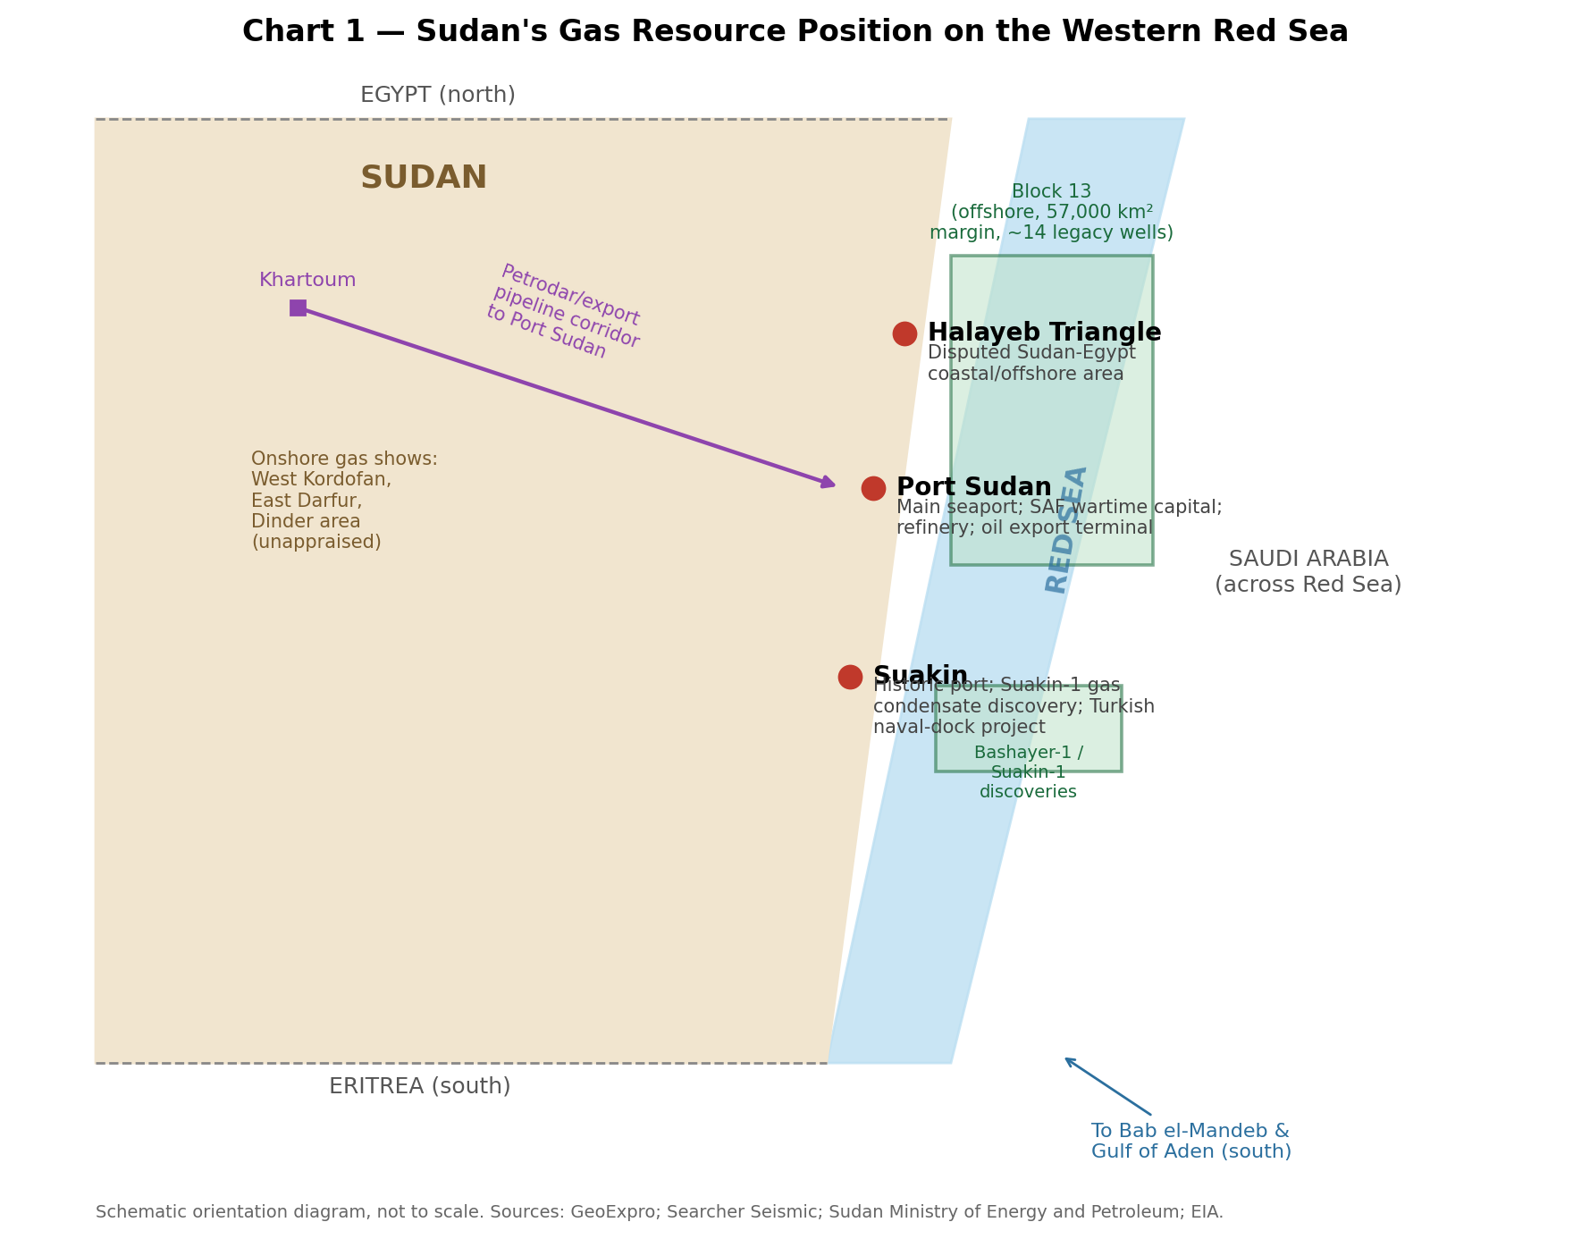
Chart 1 — Sudan's gas resource position on the western Red Sea (schematic; not to scale).

Why the Red Sea Matters Geopolitically
The Red Sea connects the Suez Canal and the Mediterranean to the Gulf of Aden and Indian Ocean through the Bab el-Mandeb strait, carrying a large share of global containerized trade and a significant volume of oil and LNG shipping between Asia, the Gulf and Europe. Analysts estimate that roughly 12% of global trade normally transits this corridor. Since late 2023, sustained Houthi attacks on merchant shipping intensifying again through 2025 and 2026 amid the wider Iran-Israel confrontation have cut daily transits through Bab el-Mandeb from a pre-crisis average of more than 70 vessels to well below 30 on several occasions, forcing many operators onto the longer Cape of Good Hope route, which adds 10-14 days and materially raises freight, insurance and delivery costs.
War-risk insurance premiums for Red Sea transits have moved sharply with the security situation: additional war-risk cover reportedly rose from roughly 0.3% to 0.7% of hull value after a July 2025 escalation, and by mid-2026, attacks on Saudi-flagged tankers near Jizan pushed premiums and diversions higher still, with Bab el-Mandeb crossings falling around 30% in a single day during acute episodes. These disruptions matter for Sudan because Port Sudan and Sudan's territorial waters sit inside the same threat envelope: any Sudanese offshore gas or LNG infrastructure would be exposed to the same insurance, security and routing risk premia affecting all Red Sea shipping, regardless of who controls the coastline politically.
Beyond commercial shipping, the Red Sea hosts a dense concentration of foreign military and naval infrastructure U.S., French, Japanese, Chinese, Saudi and other facilities cluster around Djibouti; the UAE maintains a naval presence at Assab (Eritrea); Turkey operates in Somalia; and, since February 2025, Russia has an agreed naval-basing arrangement at Port Sudan itself. Undersea telecommunications cables and, increasingly, planned electricity interconnectors (Egypt-Saudi Arabia; Egypt-Sudan) add an economic-infrastructure dimension to what was historically framed primarily as a naval and shipping chokepoint. Control of, or privileged access to, Sudan's coastline is therefore valuable to external powers independent of any gas discovery.

3. The Strategic Value of Sudan's Gas Resources
This section separates current strategic value from potential future strategic value a distinction the source material treats as critical, and one that this note applies rigorously. Undeveloped resources do not automatically confer geopolitical leverage; leverage requires production, infrastructure, offtake relationships, and a government capable of enforcing contracts.
Current strategic value: limited
At present, Sudan's gas resources have essentially no operational strategic value. There is no production, no export capability, no LNG terminal, and no functioning domestic gas-fired power sector of scale. CNPC's December 2025 withdrawal from its last Sudanese oil block (Block 6, a decision made despite CNPC having continued operating through the first two-plus years of civil war) demonstrates that even Sudan's most committed and patient foreign hydrocarbons partner now assesses the country's risk-adjusted commercial case as unworkable. If the most experienced, most politically tolerant investor in Sudanese hydrocarbons is exiting, unapprised gas prospects offer negligible near-term strategic weight.
Potential future strategic value: contingent and significant
Conditional on a durable political settlement, renewed 3D seismic and appraisal drilling on Block 13 and adjacent Red Sea acreage, restored institutional capacity at the Ministry of Energy and Petroleum, and competitive, bankable licensing terms, Sudan's location could support gas-to-power generation for its own chronically undersupplied grid, and pipeline or LNG exports positioned to serve Red Sea and East African markets. The scale of this potential cannot be responsibly quantified from public data: the 3 Tcf reserve figure is modest by regional standards (Egypt alone holds Zohr-scale fields well into the tens of Tcf), and there is insufficient evidence to conclude that Sudan's offshore prospectivity will convert into commercial discoveries of a similar order.
What must happen before gas becomes a source of leverage, in rough sequence: (1) cessation or durable de-escalation of the SAF-RSF conflict; (2) reunification of licensing and regulatory authority (currently contested between a SAF-aligned government operating from Port Sudan/Khartoum and RSF-aligned structures in Darfur/Kordofan); (3) completion of modern 3D seismic and at least one appraisal well proving commercial flow rates; (4) resolution or management of the Halayeb-area maritime boundary ambiguity with Egypt; and (5) a functioning banking and foreign-exchange system capable of supporting international project financing. None of these conditions is currently met.

4. The Regional Power Competition
External actors are ranked below by their demonstrated relevance to Sudan's Red Sea and gas-energy interests specifically, not by general influence in Sudan's civil war.
Egypt
Egypt's interests are the most structurally intertwined with Sudan's energy future. Cairo shares an electricity interconnection with Sudan (currently 80 MW, targeted for expansion to 300 MW under Egypt's 2025/26 plan) and has just brought online the region's first large-scale HVDC interconnection with Saudi Arabia (3,000 MW, entering final commercial testing in early-to-mid 2026), positioning Egypt as an aspiring regional power-trading hub linking Africa, the Gulf and prospectively Europe. Egypt also shares an unresolved maritime and territorial dispute with Sudan over the Halayeb Triangle and adjacent Red Sea waters, which overlaps with acreage Egypt has separately licensed (via GANOPE/TGS/Schlumberger seismic work) and which Sudan has publicly contested as illegal. Egypt has backed the SAF in the civil war, aligning its security and energy interests with the same faction that controls Port Sudan.
Saudi Arabia
Saudi Arabia's posture toward Sudan has shifted from mediator to institutionally embedded partner over 2025-2026. Riyadh convened the original 2023 Jeddah Declaration and Jeddah Platform talks (both of which collapsed), but by December 2025 Crown Prince Mohammed bin Salman was hosting SAF leader Abdel Fattah al-Burhan, and by August 2026 the two governments had signed a founding agreement for a Saudi-Sudanese Coordination Council, alongside plans for a Riyadh investment forum addressing roughly $50 billion in prospective projects (against existing bilateral trade of about $8 billion, dominated by livestock and agriculture, not energy). Most significantly for Red Sea security, Saudi Arabia convened a new Red Sea security coalition in July 2026 (reported signatories including Turkey, Kuwait, Bahrain, Qatar, Jordan, Egypt, Pakistan, Djibouti, Somalia, Bangladesh, Yemen, Sudan and the Comoros — notably excluding the UAE and Oman), positioning Riyadh as the convening power for Red Sea maritime security with Sudan as a member state. Credible reporting also describes Saudi financial backing for SAF operations around Port Sudan, though the precise scale is not independently verified in open sources.
United Arab Emirates
The UAE's regional strategy a network of DP World and Abu Dhabi Ports Group concessions spanning Berbera (Somaliland), Bosaso (Puntland) and Assab (Eritrea) has been explicitly described by regional analysts as using commercial port investment as an instrument of strategic access to the Red Sea and Bab el-Mandeb. In Sudan specifically, a $6 billion port and special economic zone agreement at Abu Amama (announced December 2022) was cancelled by the Sudanese government in November 2024, with Khartoum explicitly citing Emirati support for the RSF as the reason. The UAE has also been the subject of a U.S. Treasury sanctions action (January 2025, alongside the U.S. genocide determination against the RSF) targeting seven RSF-linked companies based in the UAE, and of a documented Sudan Conflict Observatory finding of arms flights from the UAE to the RSF between June 2023 and May 2024. This combination cancelled energy-adjacent infrastructure plus credible allegations of backing the SAF's principal adversary makes the UAE currently the most strategically constrained of the major external actors with respect to Sudan's own Red Sea energy assets, even as its broader Horn of Africa port network continues to expand.
Turkey
Turkey has pursued a dual-track strategy: publicly positioning itself as a mediator between the UAE and Sudan while simultaneously deepening bilateral ties with the SAF-aligned government, including a December 2025 port-twinning and humanitarian shipment arrangement (tents shipped via Mersin to Port Sudan) and a longstanding naval-dock construction project at Suakin, first agreed under the pre-2019 government and revived since. Turkish drone sales (Bayraktar TB2) to the SAF, routed partly through Chad and Eritrea to bypass 2023 U.S./EU arms restrictions, further underline Ankara's alignment with the SAF in the war for control of the coastline. Turkey's energy-infrastructure role in Sudan remains limited relative to Egypt or Saudi Arabia, but its Suakin naval project gives it a direct physical foothold that could extend to commercial port or energy-logistics functions if political conditions allow.
Russia
Russia's February 2025 agreement with Sudan to establish a naval facility at Port Sudan is, in strategic terms, the most consequential single development covered in this note, independent of gas. Coming after the loss of Syrian basing following the Assad government's collapse in December 2024 and Turkish closure of the Bosporus/Dardanelles to certain naval transits, the Port Sudan arrangement gives Russia its first Red Sea naval foothold and a platform for extending reach into the Indian Ocean and sub-Saharan Africa. Russia has no significant role in Sudan's gas sector, but its naval presence directly affects the security calculus for any future offshore or coastal gas infrastructure.
China
China's three-decade hydrocarbons relationship with Sudan effectively ended in December 2025 when CNPC formally withdrew from Block 6, invoking force majeure. A Chinese think tank cited in reporting described the withdrawal as ending China-Sudan 'oil diplomacy' entirely and warned of losses running into the billions of dollars in abandoned infrastructure, with knock-on effects for South Sudan's oil-dependent economy given the shared pipeline and refinery infrastructure. This is a strategic retreat, not an advance, and it removes the one external actor with the deepest institutional knowledge of Sudan's hydrocarbons geology and infrastructure — a gap that Gulf, Turkish or Western investors would need to fill from a much shallower base of experience.
United States and European Union
U.S. engagement is currently dominated by sanctions and humanitarian/diplomatic policy rather than energy strategy: the January 2025 genocide determination against the RSF, accompanying Treasury sanctions on Hemedti and UAE-based RSF-linked companies, and continued participation (alongside Saudi Arabia, the UAE and Egypt) in the stalled 'Quad' mediation format. There is insufficient evidence to conclude that either Washington or Brussels has an active gas-sector strategy toward Sudan; their relevance is chiefly as sanctions authorities whose designations affect which foreign companies and financial channels can legally engage with Sudanese energy projects, and as potential guarantors of any future investment-protection framework.

Table 1 — Strategic Actor Matrix
Actor | Red Sea Interest | Sudan Energy Interest | Gas Interest | Infrastructure Interest | Strategic Objective | Influence Level
Egypt | High — Suez, grid hub ambitions | High — grid link, refined products | Moderate — offshore boundary overlap | High — electricity interconnection | Regional energy-hub status; SAF-aligned stability | High
Saudi Arabia | High — new security coalition lead | Rising — investment forum, Coordination Council | Low-moderate — no direct gas deals disclosed | Moderate — financial backing, mediation | Institutionalise influence over SAF government | High
UAE | High — regional port network | Constrained — Abu Amama deal cancelled | Low — no active gas projects | High historically — now curtailed in Sudan | Regional port/logistics dominance via RSF-adjacent ties | Moderate (constrained)
Turkey | Moderate-high — Suakin foothold | Moderate — port twinning, drone sales | Low — no disclosed gas role | Moderate — Suakin naval dock | Mediator + SAF security partner; Horn of Africa profile | Moderate
Russia | High — first Red Sea naval base | Low — no gas/oil role | None disclosed | Low (energy) / High (naval) | Naval power projection, Africa/Indian Ocean reach | Moderate-high (security only)
China | Low (declining) | Declining sharply — CNPC exit Dec 2025 | Formerly high (30-year operator); now exited | Declining — abandoning assets | Damage limitation on BRI exposure | Low (falling)
United States / EU | Moderate — sanctions & shipping security | Low — no active investment | None | None | Accountability (genocide sanctions); mediation | Low-moderate (policy only)
Sources: al-Monitor; Al Jazeera; Horn Review; China-Global South Project; U.S. Department of State.

5. Ports, Gas Infrastructure and Geopolitical Influence
Port Sudan is Sudan's primary maritime lifeline and, since April 2023, functioned as the country's wartime seat of government until the SAF-aligned administration's announced return to Khartoum in January 2026; even after that shift, Port Sudan remains the principal hub for trade, humanitarian access and critically for this analysis the Petrodar export terminal and the Khartoum-linked refinery. Suakin, a smaller historic port south of Port Sudan, hosts the Suakin-1 gas-condensate discovery and is the site of Turkey's longstanding naval-dock construction project.
A useful distinction is between commercial infrastructure (a port terminal, a gas processing unit, a transmission line built and operated for economic return) and strategic infrastructure (the same physical assets valued primarily for the military access, political leverage or denial-of-access they confer on an external power). In Sudan's case, nearly every major infrastructure initiative discussed publicly over 2022-2026 blurs this line: the cancelled UAE-backed Abu Amama port/SEZ project was framed commercially but collapsed for overtly political reasons; Russia's Port Sudan naval agreement is explicitly military; and Turkey's Suakin project combines a 'civilian and military vessel' naval dock with broader economic and diplomatic aims.
Foreign participation in Sudanese energy and port infrastructure could create several forms of dependence: long-term economic dependence (through offtake contracts or infrastructure loans denominated in ways that constrain future Sudanese policy choices); strategic leverage (an external power's ability to threaten withdrawal of financing, technical support or security guarantees); political influence (informal preference for the external patron's positions in exchange for continued investment or protection); energy-security dependence (reliance on a single external supplier of electricity, fuel or, prospectively, gas); infrastructure lock-in (technical standards, equipment and maintenance contracts that favour one supplier country long after the initial deal); and explicit security obligations (naval-basing rights of the kind Russia has already secured). Because Sudan's institutions are currently divided between SAF- and RSF-aligned structures, the risk that any one of these forms of dependence becomes entrenched without the countervailing check of a unified, accountable licensing authority is elevated relative to a peacetime state.
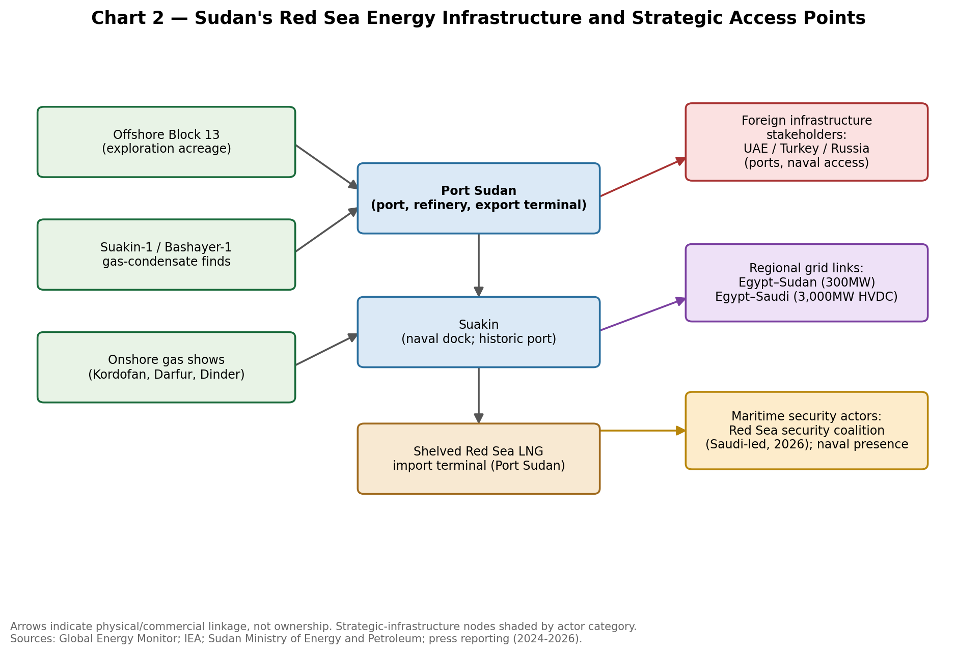
Chart 2 — Sudan's Red Sea energy infrastructure and strategic access points.

6. The Foreign Investment Competition
Several categories of potential investor could plausibly compete for future participation in Sudan's gas sector, each offering a different bundle of capital, technology and political risk tolerance. International oil companies (IOCs) with regional Red Sea experience (e.g., firms already active in Egyptian or Saudi Red Sea acreage) could bring technical expertise in salt-tectonics exploration directly relevant to Sudan's pre-salt plays, but Western IOCs face reputational and sanctions-compliance constraints given the RSF genocide determination and the SAF's own human-rights record. National oil companies from the Gulf (Saudi Aramco, ADNOC) could combine capital with geological familiarity from the opposite Red Sea shore but have shown no disclosed appetite for Sudanese gas specifically, as distinct from broader Gulf investment pledges. Turkish and Chinese state-linked firms offer a higher risk tolerance historically, but CNPC's exit signals that even China's threshold has been crossed for now. Russian energy majors have no disclosed Sudanese hydrocarbons interest, their engagement being confined to the naval domain.
In exchange for capital, technology, exploration expertise, infrastructure, market access, security guarantees, financing or political relationships, Sudan would typically be expected to offer some combination of: production-sharing terms favorable to the investor, port or logistics concessions, exclusivity or first-refusal rights on future blocks, and in the security domain basing, overflight or access arrangements. The central risk this note flags is that in a divided, contested political environment, such concessions are more likely to be negotiated by whichever faction currently controls the relevant territory (chiefly the SAF at Port Sudan) than through a competitive, transparent process raising the probability that commercial investment becomes a vehicle for broader strategic influence rather than a neutral, arm's-length transaction. There is insufficient evidence in open sources to conclude that any specific production-sharing or infrastructure-concession negotiation for Sudanese gas is currently underway with a named foreign company; the risk described here is structural and anticipatory rather than a report of an active deal.

7. Gas Infrastructure as a Tool of Geopolitical Influence
Ownership, operation, financing and long-term contractual control are analytically distinct and do not automatically converge. A foreign company can own equity in a Sudanese gas block without that translating into its home government's political control over Sudan; conversely, a nominally Sudanese-owned facility financed and technically operated end-to-end by a single foreign state entity, under a long-dated offtake contract, can constitute de facto strategic dependence even without formal ownership. The conditions under which commercial investment becomes strategic leverage typically include:
(a) a single external actor holding a dominant or exclusive position (rather than one player among several competing investors);
(b) financing structured through sovereign or quasi-sovereign lending rather than commercial capital markets, increasing the state-to-state character of the relationship;
(c) technical lock-in through proprietary standards or exclusive maintenance arrangements; and (d) the bundling of energy deals with security or basing arrangements, as appears to be occurring in Sudan's port sector even absent a comparable gas deal to date.
Given the absence of a mature, competitively licensed gas sector in Sudan, none of these conditions can yet be assessed as fully present for gas specifically but the port and electricity sectors already show several of these features, and would likely serve as the template for any future gas deal.

8. Maritime Security and the Gas Question
Sudan's internal conflict has not, to date, directly targeted offshore Red Sea assets, but it has repeatedly struck Port Sudan itself: a wave of drone attacks in May 2025 hit the city's airport, a fuel depot, the Marina Hotel area and the Flamingo military base, drawing condemnation from the UAE and Iran alike and forcing the SAF to route some logistics through Eritrean ports instead. Territorial control maps through mid-2026 consistently show the SAF holding the entire Red Sea coastline, Port Sudan, Kassala and the eastern corridor, while the RSF dominates Darfur and contests parts of Kordofan and Blue Nile state meaning the coastline itself has, for now, avoided becoming an active front line, but remains within range of long-distance drone strikes.
Layered on top of Sudan's domestic conflict is the broader Red Sea shipping-security crisis driven by Houthi attacks, which by mid-2026 had cut Bab el-Mandeb traffic to well below pre-2023 levels and pushed war-risk insurance premiums sharply higher during acute episodes (including strikes on Saudi-flagged tankers near Jizan in July 2026). Any future Sudanese offshore exploration, gas terminal or LNG shipping activity would sit inside this same elevated-risk insurance and security environment, compounding not separate from Sudan's domestic conflict risk. Piracy risk in the southern Red Sea and Gulf of Aden, while historically lower than in the 2008-2012 period, remains a residual factor insurer continue to price.
The compounding effect on project financing is direct: elevated war-risk marine insurance, harder-to-secure political-risk insurance for onshore and offshore assets, and lenders heightened due-diligence requirements in a genocide-sanctioned conflict zone all raise the cost of capital for any Sudanese gas project well above regional peers, independent of the underlying geology.
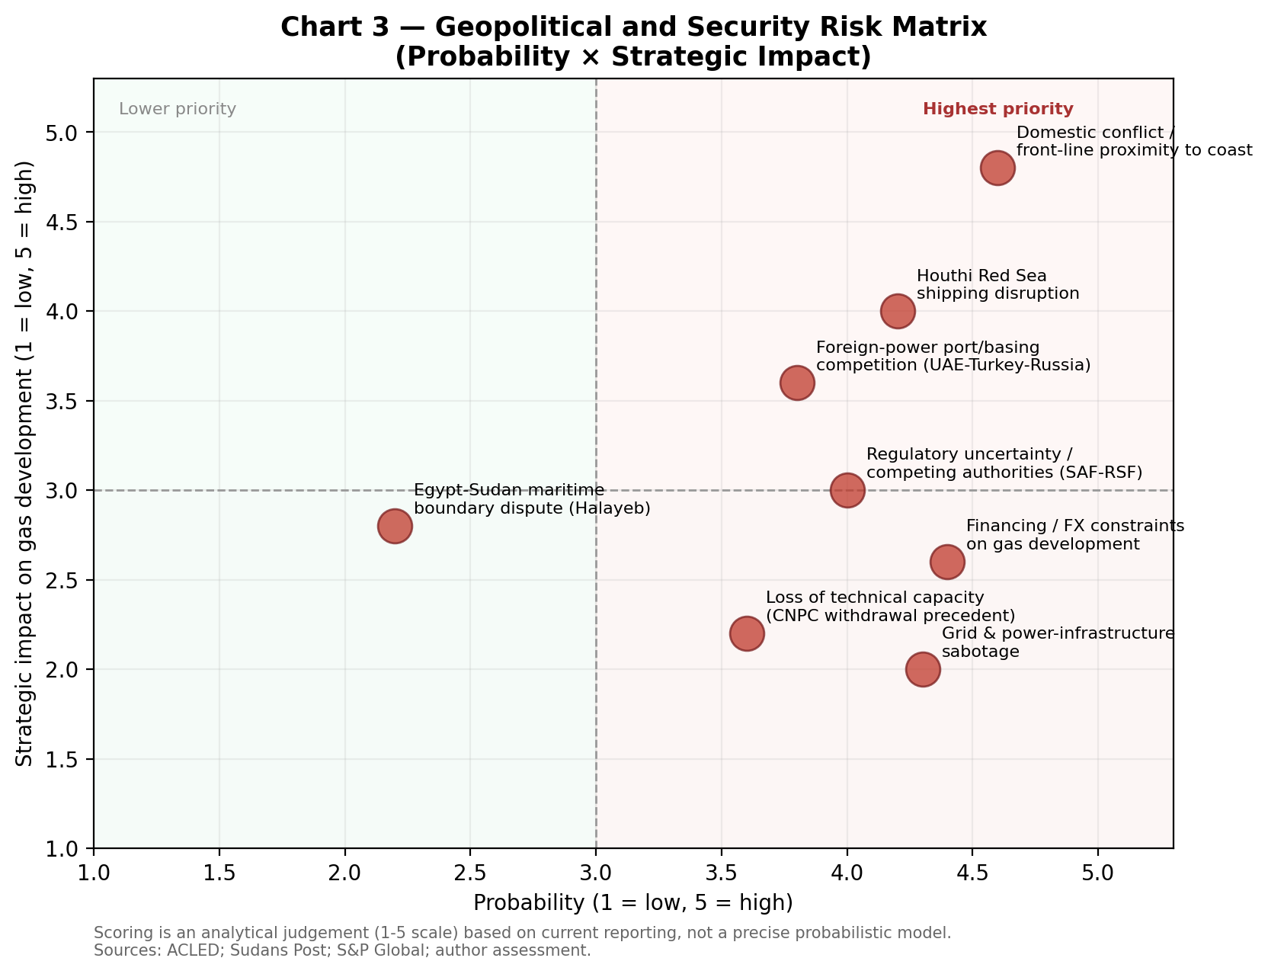
Figure 3 — Geopolitical and security risk matrix (probability × strategic impact); analytical scoring, not a formal probabilistic model.

9. Sudan's Energy Security and Strategic Dependence
Sudan's domestic energy position is acutely vulnerable, and this vulnerability is a more immediate driver of energy policy than any gas-export ambition. The Merowe Dam supplies an estimated 45-50% or more of national electricity generation; repeated RSF drone attacks on its transmission infrastructure since 2023 including a major fire-triggered outage in mid-2026 that knocked out supply to River Nile, Red Sea and Northern states plus Khartoum have caused blackouts lasting up to 18 hours a day in affected areas. Sudanese officials estimate that roughly 60% of electricity-sector infrastructure nationwide has been damaged or destroyed since the war began, and the national electricity company's 2026 rehabilitation budget request (roughly $375 million) remains unfunded amid competing wartime fiscal demands. Sudan has partly compensated through emergency electricity imports from Egypt, underscoring an immediate, non-gas dimension of energy dependence that already exists.
Three illustrative pathways frame Sudan's medium-term options:
Pathway A — Imported gas/energy dependence
Sudan continues to rely on imported electricity (from Egypt), imported refined fuel products, and potentially imported LNG (via the shelved but revivable Port Sudan terminal concept) rather than developing domestic gas. This offers the fastest route to reducing blackouts but entrenches reliance on external suppliers and foreign exchange and does nothing to build sovereign energy capacity.
Pathway B — Domestic gas development
Sudan prioritises appraisal and development of its own onshore and offshore gas for power generation and industrial use. This offers the greatest long-run autonomy but requires the political stability, financing and technical capacity Sudan currently lacks, and carries a multi-year lead time before any gas could reach the grid.
Pathway C — Mixed strategy
Sudan combines near-term imports and grid-repair investment (leaning on Egypt and, prospectively, Gulf financing) with a phased, competitively licensed domestic gas appraisal programme, alongside continued investment in solar and wind capacity (a 100 MW solar project at Dongola and a 50 MW wind project in Red Sea state have reportedly been initiated). This pathway offers the most realistic balance of near-term relief and longer-term autonomy and is the pathway this note assesses as most consistent with Sudan's actual resource and institutional constraints.
On the criterion of energy security and geopolitical autonomy specifically, Pathway C offers the best available balance: it does not require Sudan to bet its immediate power supply on unproven offshore gas, while still preserving optionality to develop domestic resources once conditions allow provided the diversification of import and investment partners (rather than concentration in any single foreign patron) is maintained as a deliberate policy choice.

10. The Red Sea Energy Corridor
Existing regional energy infrastructure already links Sudan to its neighbors in modest but real ways: an 80 MW Egypt-Sudan electricity interconnection (targeted for expansion to 300 MW under Egypt's FY2025/26 plan) and Egypt's own newly-operational 3,000 MW HVDC interconnection with Saudi Arabia (entering final commercial testing in early-to-mid 2026) together illustrate Egypt's ambition to become a regional 'energy bridge' linking Africa, the Gulf and, prospectively, Europe via the proposed GREGY link to Greece. Sudan's role in this emerging corridor is currently peripheral and asymmetric a recipient of Egyptian power rather than a contributor reflecting its own generation shortfall rather than surplus capacity to export.
A future role for Sudan as a gas or LNG contributor to this corridor, or as a host for renewable and hydrogen projects serving regional markets, remains conceptual. There is insufficient evidence to conclude that hydrogen or other emerging fuel technologies are currently relevant to Sudan's strategic position, and this note declines to force such a connection. The most plausible near-to-medium-term connectivity gains for Sudan lie in electricity expanding and stabilizing the Egypt link, and potentially adding renewable generation (solar at Dongola, wind in Red Sea state) that could, over time, support limited cross-border electricity trade rather than in gas or LNG trade, which would require a multi-year development runway Sudan does not currently have underway.
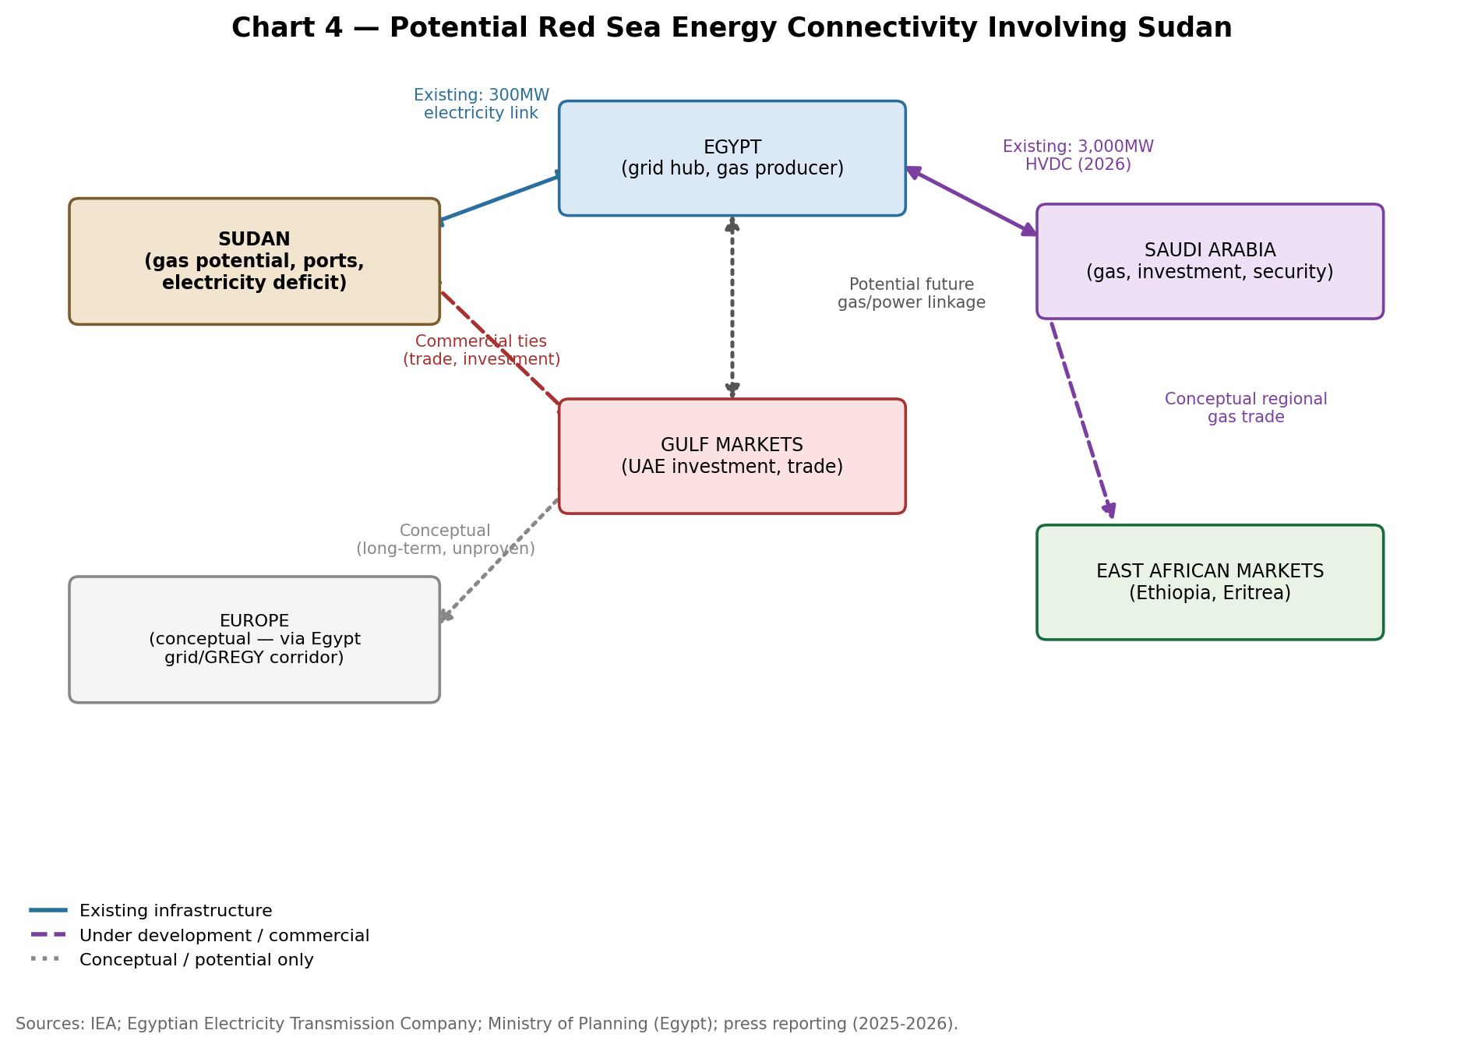
Chart 4 — Potential Red Sea energy connectivity involving Sudan; existing links shown solid, conceptual links shown dotted.

11. Sudan's Bargaining Power
Sudan's potential bargaining assets are real but currently unrealised: gas resources and offshore acreage (unappraised); ports (Port Sudan, Suakin) with genuine strategic value already demonstrated by the intensity of foreign interest in them; maritime access along a contested but globally significant sea lane; a domestic electricity market with substantial unmet demand that could, in principle, attract investment on commercial terms; and a geographic position that multiple external powers (Egypt, Saudi Arabia, UAE, Turkey, Russia) simultaneously value for different reasons, which in a counterfactual scenario of political stability could allow Sudan to play these interests against one another to extract better terms.
Sudan's constraints, however, currently dominate: active civil war with contested territorial control; a bifurcated governing authority (SAF-aligned government now nominally back in Khartoum, RSF-aligned structures consolidating parallel administration in Darfur and parts of Kordofan); catastrophic damage to core energy infrastructure; acute foreign-exchange and banking-sector dysfunction impeding cross-border investment (explicitly cited as a barrier in Saudi-Sudan investment-forum planning); the loss of Sudan's most experienced hydrocarbons partner (China/CNPC); heightened security risk affecting insurance and financing costs; and unresolved regulatory and territorial questions, including the Halayeb-area maritime boundary dispute with Egypt.
On balance, this note assesses Sudan as currently a strategically vulnerable state rather than a strategic asset or a strategic opportunity in the conventional sense. A 'strategic asset' would imply Sudan already commands external actors' deference because of what it controls; a 'strategic opportunity' would imply low-risk, high-upside potential for investors. Neither describes Sudan's present position: instead, its coastline and resources are valuable enough to attract sustained external competition, but its institutional fragmentation prevents it from capturing the benefits of that competition on favourable terms a pattern consistent with the port and naval-basing deals concluded to date, several of which have been struck with the SAF-aligned faction alone, cancelled amid factional accusations (Abu Amama), or negotiated in the absence of any unified national counterpart capable of representing Sudan's interests as a whole.

12. Scenario Analysis (5-10 Year Horizon)
Scenario 1 — Fragmented External Influence
Multiple foreign powers Egypt, Saudi Arabia, Turkey, Russia, with the UAE partially re-engaging continues pursuing separate commercial and security interests in Sudan without any one actor establishing dominant influence. Port concessions, naval arrangements and electricity links proceed piecemeal; gas development remains stalled at the appraisal stage due to continued financing and security constraints. Sudan's bargaining position is weak but not captured by a single patron, preserving some future optionality once conditions stabilize. This is broadly a continuation of the pattern observed through 2025-2026.
Scenario 2 — Regional Energy Alignment
Sudan's energy and Red Sea strategy converge increasingly around Egypt and the Gulf states (chiefly Saudi Arabia), building on the trajectory visible in the August 2026 Saudi Sudanese Coordination Council and the Saudi-led Red Sea security coalition Sudan has joined. Infrastructure integration deepens (expanded Egypt electricity links, potential Gulf-financed port and gas-appraisal investment), offering Sudan improved energy security and a degree of protection under the Saudi-led security umbrella, at the cost of increasing strategic dependence on a Riyadh-Cairo axis and a corresponding loss of negotiating leverage with other external actors.
Scenario 3 — External Power Competition
Competition among external powers intensifies rather than resolves: Russia deepens its Port Sudan naval presence, Turkey expands its Suakin foothold, the UAE seeks renewed port access (possibly through a different Sudanese counterpart or a change in the conflict's trajectory), and Gulf rivals compete for influence over the same coastal assets. Any gas development becomes entangled with this broader contest, with licensing decisions driven by strategic alignment rather than commercial merit. This scenario carries the highest geopolitical risk and the lowest Sudanese strategic autonomy of the three and is consistent with the 'fragmented governance and legitimacy' dynamic already noted in regional reporting on the Turkey-Sudan port pact and competing UAE, Saudi and Turkish initiatives.
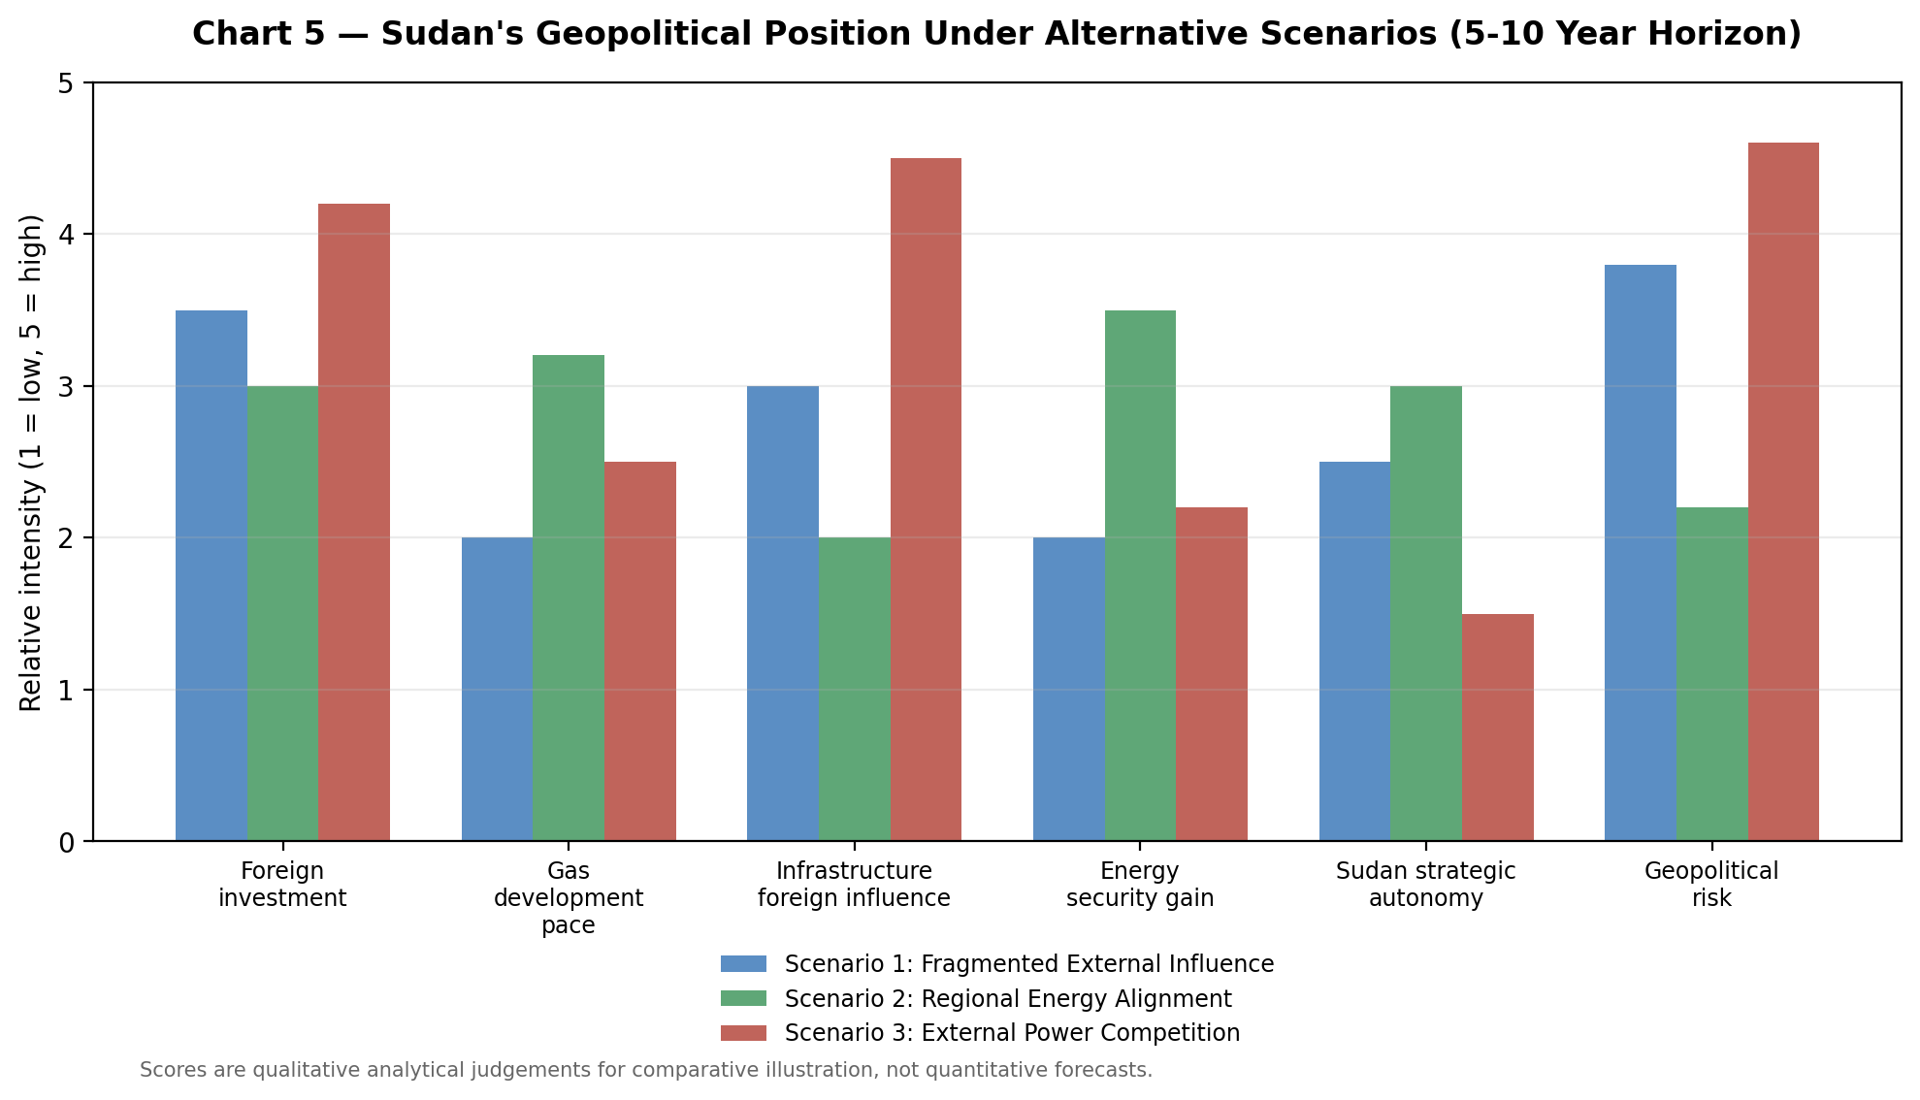
Chart 5 — Sudan's geopolitical position under alternative scenarios (illustrative comparative scoring).

13. Strategic Implications for Sudan
Egypt and Saudi Arabia are currently the most structurally important actors to Sudan's gas and Red Sea energy strategy, given existing electricity interconnection, the new Saudi Sudanese Coordination Council, and Saudi leadership of the new Red Sea security coalition.
The UAE currently poses the most acute strategic and reputational risk for any Sudanese-government energy dealing, given credible sanctions findings and the cancelled Abu Amama deal though this could shift if the conflict's political trajectory changes.
Diversified Gulf and regional partnerships (Saudi Arabia, Egypt, and potentially a re-engaged UAE or Qatar under different political conditions) offer greater long-run economic benefit than concentrated reliance on any single patron, including Turkey or Russia, whose interests in Sudan are currently weighted toward naval/security access rather than commercial energy development.
Sudan should avoid excessive dependence on any one external power for financing, offtake or security guarantees; the Abu Amama cancellation illustrates the political risk of concentrated foreign infrastructure deals struck amid an active civil war.
Port and gas infrastructure agreements should be structured to separate commercial terms from security/basing arrangements wherever possible, with sunset clauses, competitive-bidding requirements for follow-on phases, and clear dispute-resolution mechanisms.
Contract safeguards should include local-content and technology-transfer requirements, fiscal-stability clauses that survive changes in the controlling faction, and explicit provisions addressing the Halayeb-area boundary ambiguity with Egypt before any offshore licensing round proceeds in contested acreage.
Gas infrastructure particularly any future LNG terminal, processing facility or trunk pipeline should be treated as strategic national infrastructure requiring transparent, centrally coordinated licensing, not ad hoc deals struck by whichever faction controls the relevant territory at a given moment.
Competitive bidding, run by a reunified and internationally credible licensing authority once political conditions allow, is the single most effective lever Sudan has to improve its bargaining position, by preventing any one external actor from securing exclusive or preferential access.
Converting Red Sea geography into economic value without surrendering strategic autonomy will require Sudan to pursue commercial infrastructure revenue (port fees, transit fees, electricity trade) while resisting the bundling of commercial deals with exclusive security or basing concessions to any single foreign power.

Strategic Outlook
Over the next five to ten years, Sudan's most probable trajectory absent a decisive and durable political settlement is continued fragmented external competition for its coastline and ports (Scenario 1), with a meaningful chance of drift toward deeper alignment with a Saudi-Egyptian axis (Scenario 2) if the Coordination Council and Red Sea security coalition frameworks mature, and a persistent risk of intensified great-power and regional-power competition (Scenario 3) if the civil war entrenches further or if Russia's and Turkey's coastal footholds expand in ways that provoke competitive responses from Saudi Arabia, Egypt or a re-engaging UAE. Gas development itself is unlikely to be the decisive variable in any of these paths over this horizon; it will instead follow, rather than lead, the resolution of Sudan's political and security crisis. Policymakers, investors and energy-sector decisionmakers should treat Sudanese gas as a multi-year, high-risk optionality play contingent on political normalization, and should monitor the coastline and port competition not the gas licensing calendar as the leading indicator of how Sudan's Red Sea position is evolving.

Supporting Tables
Table 2 — Sudan's Red Sea Energy Infrastructure
Asset | Type | Status | Strategic Note
Port Sudan | Port / refinery / export terminal | Operational; SAF-controlled | Primary maritime lifeline; Petrodar oil export terminal; wartime seat of government to Jan 2026
Suakin | Historic port / naval dock | Under development (Turkey) | Site of Suakin-1 gas-condensate discovery; Turkish naval-dock project
Port Sudan LNG import terminal | LNG import terminal (proposed) | Shelved | Was intended to feed Port Sudan power plant and Khartoum pipeline
Block 13 (offshore) | Exploration acreage | Unappraised / legacy seismic only | 57,000 km² margin; ~14 legacy wells; 2D/3D seismic reprocessing by Searcher
Suakin-1 / Bashayer-1 | Gas-condensate discoveries | Discovered 1970s; never appraised | Only confirmed offshore hydrocarbon discoveries in Sudanese Red Sea waters
Petrodar pipeline | Crude oil pipeline (500,000 bpd) | Operational (oil, not gas) | Links South Sudan Melut Basin to Port Sudan refinery/export terminal
Merowe Dam | Hydropower (~1,200-1,250 MW) | Repeatedly damaged by drone strikes | Supplies ~45-50%+ of national electricity; single point of failure
Egypt-Sudan interconnector | Electricity transmission | Operational (80MW); expansion to 300MW planned | Sudan's primary external electricity lifeline
Russia Port Sudan naval facility | Naval base | Agreed Feb 2025 | First Russian Red Sea naval foothold; security, not energy, asset

Table 3 — Foreign Investment and Strategic Influence Channels
Channel | Example in Sudan | Commercial or Strategic? | Leverage Risk
Port concession | Abu Amama (UAE, cancelled Nov 2024) | Mixed — framed commercial, collapsed for political reasons | High — demonstrated by cancellation amid RSF-backing allegations
Naval basing agreement | Russia, Port Sudan (Feb 2025) | Strategic | High — explicit military access, not gas-linked but coastal
Naval-dock construction | Turkey, Suakin | Mixed | Moderate — could extend to commercial energy-logistics role
Electricity interconnection | Egypt-Sudan (80MW, expanding) | Commercial, state-to-state | Moderate — dependence on Egyptian supply during outages
Exploration licence / PSA | None currently active in Sudan offshore Red Sea | Would be commercial | Depends on licensing process transparency
Sovereign investment pledges | Saudi $3bn (2022) / $50bn forum pledges (2026) | Mixed — commercial framing, geopolitical context | Rising — tied to Coordination Council institutionalisation
Arms/logistics support | UAE-RSF (sanctioned); Turkey-SAF (drones) | Strategic, war-related | High — directly shapes which faction controls coastal assets
Table 4 — Geopolitical Risk Matrix (Summary)
Risk | Probability (1-5) | Strategic Impact (1-5) | Priority
Domestic conflict / front-line proximity to coast | 4.6 | 4.8 | Highest
Houthi Red Sea shipping disruption | 4.2 | 4.0 | Highest
Regulatory uncertainty / competing authorities (SAF-RSF) | 4.0 | 3.0 | High
Foreign-power port/basing competition (UAE-Turkey-Russia) | 3.8 | 3.6 | High
Financing / FX constraints on gas development | 4.4 | 2.6 | High
Loss of technical capacity (CNPC withdrawal precedent) | 3.6 | 2.2 | Moderate
Grid & power-infrastructure sabotage | 4.3 | 2.0 | Moderate
Egypt-Sudan maritime boundary dispute (Halayeb) | 2.2 | 2.8 | Moderate-lower
Scoring is an analytical judgement on a 1-5 scale based on current open-source reporting, not a formal quantitative model.

Table 5 — 5 to 10-Year Geopolitical Scenarios (Summary)
Scenario | Foreign Investment | Gas Development Pace | Sudan Strategic Autonomy | Geopolitical Risk
1. Fragmented External Influence | Moderate, dispersed | Slow | Moderate | Moderate-high
2. Regional Energy Alignment (Egypt/Saudi-led) | Moderate, concentrated regionally | Moderate | Moderate (traded for security umbrella) | Lower
3. External Power Competition (intensified) | High but contested | Slow (politically entangled) | Low | Highest

Reference
U.S. Energy Information Administration (EIA) country data on Sudan, referenced via aenert.com and Al Jazeera (November 2025) energy-resource reporting.
GeoExpro and Searcher Geodata UK Ltd, technical reporting on Sudan's Red Sea offshore geology and seismic exploration (2022).
Global Energy Monitor, Sudan Red Sea LNG Terminal project record (2025).
International Energy Agency (IEA), Egypt-Saudi Electricity Interconnection Project policy record; Egyptian Ministry of Planning, Economic Development and International Cooperation (2025/26 plan reporting).
China-Global South Project, reporting on CNPC's December 2025 withdrawal from Sudan and 2025 Belt and Road energy investment overview.
S&P Global Commodity Insights and Al Jazeera, Red Sea shipping and insurance reporting (2025-2026).
Sudans Post geospatial territorial-control mapping (March-June 2026); Council on Foreign Relations Global Conflict Tracker; armedconflicts.org Sudan civil war tracker.
Al Jazeera, Al-Monitor, Horn Review, and the Middle East Institute, reporting on Saudi Arabia, UAE, Turkey and Russia's Red Sea and Sudan-specific engagement (2025-2026).
U.S. Department of State and Human Rights Watch, documentation of the January 2025 RSF genocide determination and associated sanctions.
Middle East Council on Global Affairs and Arab News, reporting on Sudan's electricity-sector crisis and Merowe Dam outages (2025-2026).

