Algeria as North Africa's Gas Hub: Leveraging Resources and Infrastructure to Strengthen Regional Energy Security
Executive Summary
Algeria has long occupied a strategic position within the global natural gas market, leveraging one of Africa's largest proven gas reserve bases, an extensive network of cross-border export pipelines, and well-established liquefied natural gas (LNG) infrastructure to become North Africa's foremost gas hub. Anchored by the giant Hassi R'Mel field and Sonatrach, that controls the full value chain from wellhead to export terminal, Algeria combines a large conventional reserve base with decades of infrastructure investment: two operating intercontinental pipelines (TransMed to Italy and Medgaz to Spain), a dormant third line through Morocco, and four liquefaction trains at Arzew and Skikda with a combined nameplate capacity of roughly 25 million tonnes per annum.
The country's gas sector is underpinned by approximately 4.5 trillion cubic metres (tcm) (about 159 trillion cubic feet) of proven natural gas reserves, ranking among the largest globally and second only to Nigeria within Africa. Production is concentrated in the prolific Illizi, Berkine, Ahnet-Timimoun, and Reggane basins, with mature super-giant fields such as Hassi R'Mel continuing to anchor domestic supply and export capacity. Over the past two decades, Algeria has pursued a dual strategy of sustaining production from mature assets while developing new gas provinces through partnerships with international oil companies (IOCs), enhanced recovery programmes, and targeted exploration campaigns.

Algeria's Natural Gas Reserve Base and Production Profile
Natural gas constitutes the foundation of Algeria's hydrocarbon economy and remains the country's most strategically significant energy resource. Since the discovery of the Hassi R'Mel gas field in 1956, Algeria has developed a highly integrated gas industry encompassing upstream production, processing, transportation, LNG liquefaction, domestic distribution, and international exports. Algeria holds among the largest proved conventional natural gas reserves in Africa, estimated at approximately 159 trillion cubic feet (roughly 4.5 trillion cubic metres) as of the early 2020s, with national regulator ALNAFT citing a slightly higher figure of around 4,500 bcm at end-2024. This conventional base is complemented by what Sonatrach describes as the world's third-largest shale gas endowment, with un-risked resources variously estimated between 700 trillion cubic feet and roughly 20,000 bcm, concentrated in the Ahnet, Berkine, Illizi and Timimoun basins of the southern Sahara. Reserves are heavily concentrated: the Hassi R'Mel wet gas field, discovered in 1956 and still Africa's largest gas field, alone accounts for around a quarter of national daily production and anchors both the domestic transmission grid and the export pipeline network.
Production has been volatile over the past decade, shaped by field maturation, underinvestment in the 2015–2020 period, and a wave of delayed south-western development projects. Marketed output fell in 2024 before stabilising, with the World Bank and Wood Mackenzie projecting moderate growth through 2025–2027 before a plateau, as phase 1 and phase 2 projects in the south-west (among them Reggane Nord, Timimoun and Touat) come progressively onstream, albeit with several projects proving technically difficult and prompting downward revisions to earlier recoverable-reserve estimates. Sonatrach's current five-year plan (2024–2028) is explicit about the production challenge: roughly 70% of the announced US$50 billion capital programme is earmarked for exploration and production, including three new compression stations at Hassi R'Mel scheduled for completion by 2027 that are intended to unlock an incremental ~121 bcm of recoverable gas over the field's remaining life.

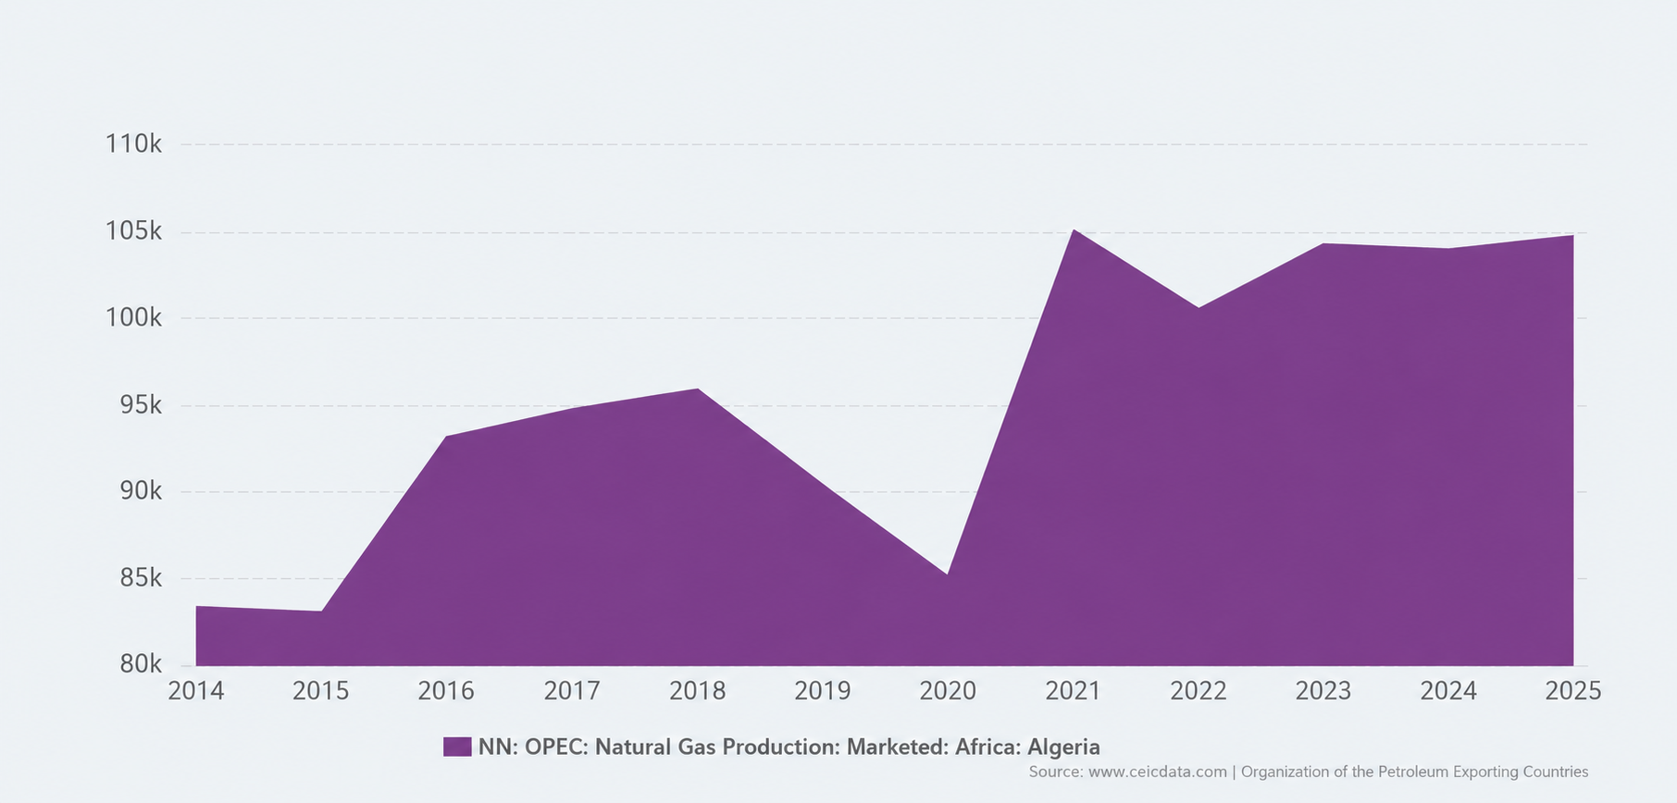

Figure 1 Algeria Natural Gas Production (2014-2025)

Geological Endowment
Algeria's hydrocarbon resources are distributed across several sedimentary basins, most of which lie within the Sahara Desert. These basins contain both conventional and unconventional gas accumulations formed over multiple geological periods. The principal gas-producing basins include:
- Illizi Basin (Key producing assets include: In Amenas, In Salah, Ohanet, and Tinrhert developments)

Berkine Basin

Ahnet Basin

Reggane Basin

Timimoun Basin
These basins host most of Algeria's conventional gas reserves and continue to attract exploration and development investment.
Major Gas Fields and Production Area
Field/Area | Basin/Region | Significance
Hassi R'Mel | Central Sahara | Africa's largest gas field; anchors domestic grid and export pipeline network; ≈ 26% of national daily gas production
Reggane Nord | South-west Algeria | Phase 1/2 development; among the delayed but strategically important new-supply projects
Timimoun | South-west Algeria | Joint development supporting the south-west production growth wave
Touat | South-west Algeria | Recent new-field addition supporting production recovery
Ahnet / Berkine / Illizi basins | Southern Sahara | Core shale gas resource areas targeted by Chevron and ExxonMobil evaluation MOUs
Tin Fouyé Tabankort II & Sud (TFT) | Southern Algeria | Sonatrach–TotalEnergies JV; combined output targeted to exceed 100,000 boe/d by 2026

Algeria Natural Gas Reserve Snapshot
Metrics | Estimate | Notes
Proved conventional reserves | ≈ 159 Tcf (≈ 4.5 Tcm) | EIA / Holland & Knight, early-2020s vintage
Proved reserves (ALNAFT, end-2024) | ≈ 4,504 bcm | Cited in Algeria Bid Round 2026 documentation
Un-risked shale gas resources | 700 Tcf – ≈ 20,000 bcm (wide range across sources) | Ranked among world's largest shale endowments; Ahnet, Berkine, Illizi, Timimoun basins
Proved oil reserves | ≈ 12.2 billion barrels | Third-largest in Africa
Marketed gas production, 2023–25 | ≈ 105–113 bcm/year | Recovering from 2024 dip; growth resuming 2025–26
Government production target | ≈ 200 bcm/year by 2030 | Sonatrach five-year plan; implies ~50% uplift on current output

Domestic Gas Demand versus Export Commitments
Domestic consumption has grown steadily, driven by a subsidised residential and industrial tariff regime, rapid growth in gas-fired power generation (which supplies the large majority of Algeria's electricity), and increasing reinjection of gas for enhanced oil recovery. Domestic demand is estimated to have risen from roughly 40 bcm in 2019 to over 50 bcm by 2025 as shown in figure 2, and continues to grow at a pace that increasingly competes with exportable surplus, a dynamic that is the central strategic tension in Algeria's gas policy. Because domestic gas is priced well below export parity, rising internal consumption represents a direct opportunity cost against higher-value pipeline and LNG sales.
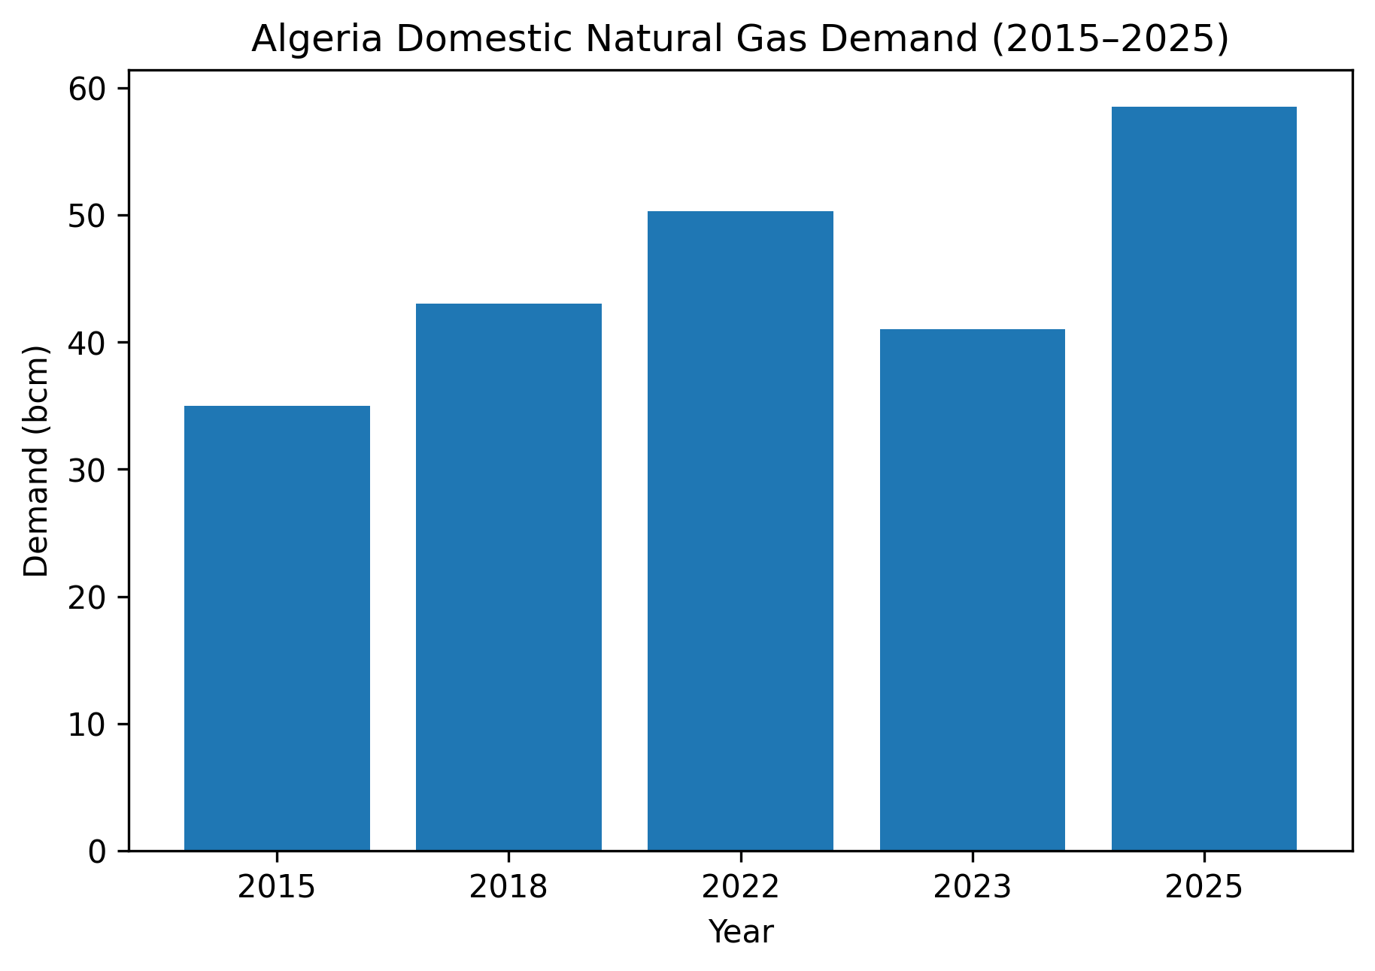
Figure 2 Algeria Domestic Natural Gas Demand
Algeria has historically prioritised long-term contractual export commitments, particularly to Italy, Spain, France and Turkey, and has generally avoided outright curtailment of exports even during periods of tight domestic supply, instead drawing down spare capacity in the TransMed pipeline and its LNG trains. The government's public target of 200 bcm/year production by 2030 is explicitly framed as a mechanism to expand the export availability without constraining domestic supply, alongside efficiency measures such as gas-to-power heat-rate improvements, subsidy reform discussions, and a renewed push on solar generation intended to displace some domestic gas burn over the next decade. The domestic-export balance therefore functions as Algeria's principal monetisation lever: every incremental bcm freed from the domestic market via efficiency or new supply converts directly into export revenue at a substantial price uplift.
At the centre of Algeria's natural gas industry is Sonatrach, one of Africa's largest national oil companies (NOCs) and the principal architect of the country's gas monetisation strategy. Established in 1963 following Algeria's independence, Sonatrach has evolved from a domestic hydrocarbon operator into an integrated energy company with responsibilities spanning the entire gas value chain from exploration and production to processing, transportation, liquefaction, marketing, and international trading. Figure 2 shows the role of Sonartrach in gas development.
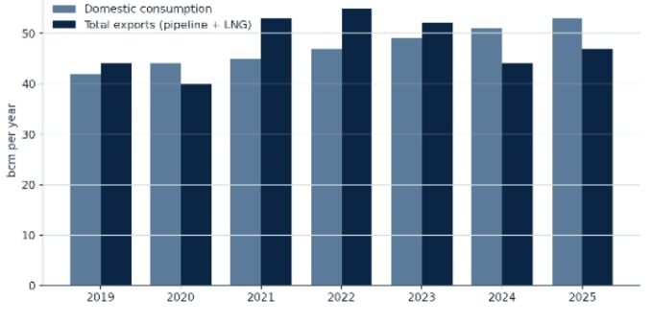
Figure 3 Sonatrach's Strategic Role in Gas Development
The 2019 Hydrocarbons Law, and subsequent amendments, sought to make Algeria's fiscal and contractual terms more competitive for foreign investors after a decade of declining exploration activity, introducing more flexible production-sharing structures and reduced royalty burdens for higher-risk frontier and unconventional acreage. Sonatrach has also begun to diversify its own mandate beyond hydrocarbons, integrating solar power at oil and gas sites, launching a 2024 climate strategy on methane and flaring reduction, and pursuing green and blue hydrogen partnerships.
Pipeline Network
Algeria's export pipeline system was built in three successive waves and remains the backbone of its European gas relationship. The Trans-Mediterranean Pipeline (TransMed, also known as the Enrico Mattei pipeline), commissioned in 1983, runs roughly 2,475 km from Hassi R'Mel through Tunisia and under the Sicilian Channel to mainland Italy, with onward extensions into Slovenia and, since 2023–24, the Czech market. Its nameplate capacity is approximately 30–33.5 bcm/year, jointly operated with Eni through the TMPC joint venture.
Medgaz, a direct subsea link from the Algerian coast to Almeria, Spain, commissioned in 2011, has a nameplate capacity of roughly 10.5–10.7 bcm/year following a 2022 capacity expansion, and is now operating close to full capacity, carrying a record 9.4 bcm in 2024; expansion discussions initiated in early 2026 aim to add a further ≈1 bcm/year of throughput, though any physical capacity addition will take several years to engineer and commission.
The third intercontinental route, the Maghreb-Europe Gas Pipeline (GME, or Pedro Duran Farell pipeline), running via Morocco to Cordoba with onward links to Portugal, has a design capacity of roughly 12–13 bcm/year but has been shut since October 2021 amid the diplomatic rupture between Algeria and Morocco. A reopening is considered unlikely while bilateral tensions persist, representing a structurally lost corridor of flexibility for Iberian supply.
A longer-horizon regional project, the Trans-Saharan Gas Pipeline (TSGP), intended to carry up to 30 bcm/year of Nigerian gas across Niger to the Algerian network for onward export via TransMed or as LNG, regained diplomatic momentum in 2025–26 following a rapprochement between Algiers and Niamey. Following the approval of the updated feasibility study in June 2026, construction commenced on the Algerian segment of the Trans-Saharan Gas Pipeline (TSGP). While the full Nigeria–Niger–Algeria corridor remains under phased development, the project has progressed beyond the proposal stage and entered active execution.

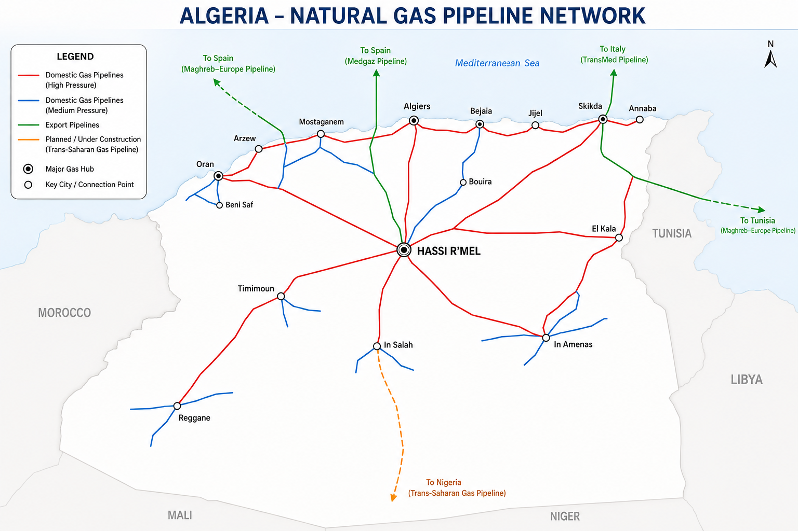
Figure 4 Map Showing Algeria Pipeline Network
LNG Export Infrastructure
In addition to pipeline exports, Algeria possesses one of Africa's oldest and most established LNG industries. Today the country operates two liquefaction complexes: the Arzew/Bethioua site, comprising the GL1Z and GL2Z trains with a combined nameplate capacity of roughly 20.8 mtpa, and the modern GL3Z train commissioned in 2014 and the Skikda complex, whose GL1K train (rebuilt after a fatal 2004 explosion and recommissioned in 2013) has a nameplate capacity of approximately 4.5 mtpa. Industry estimates from GIIGNL put combined operational LNG export capacity at roughly 25.3 mtpa, though independent assessments suggest effective, reliably operable capacity is estimated at approximately 14–18 mtpa reflecting the age of the Arzew trains and periodic unplanned outages.

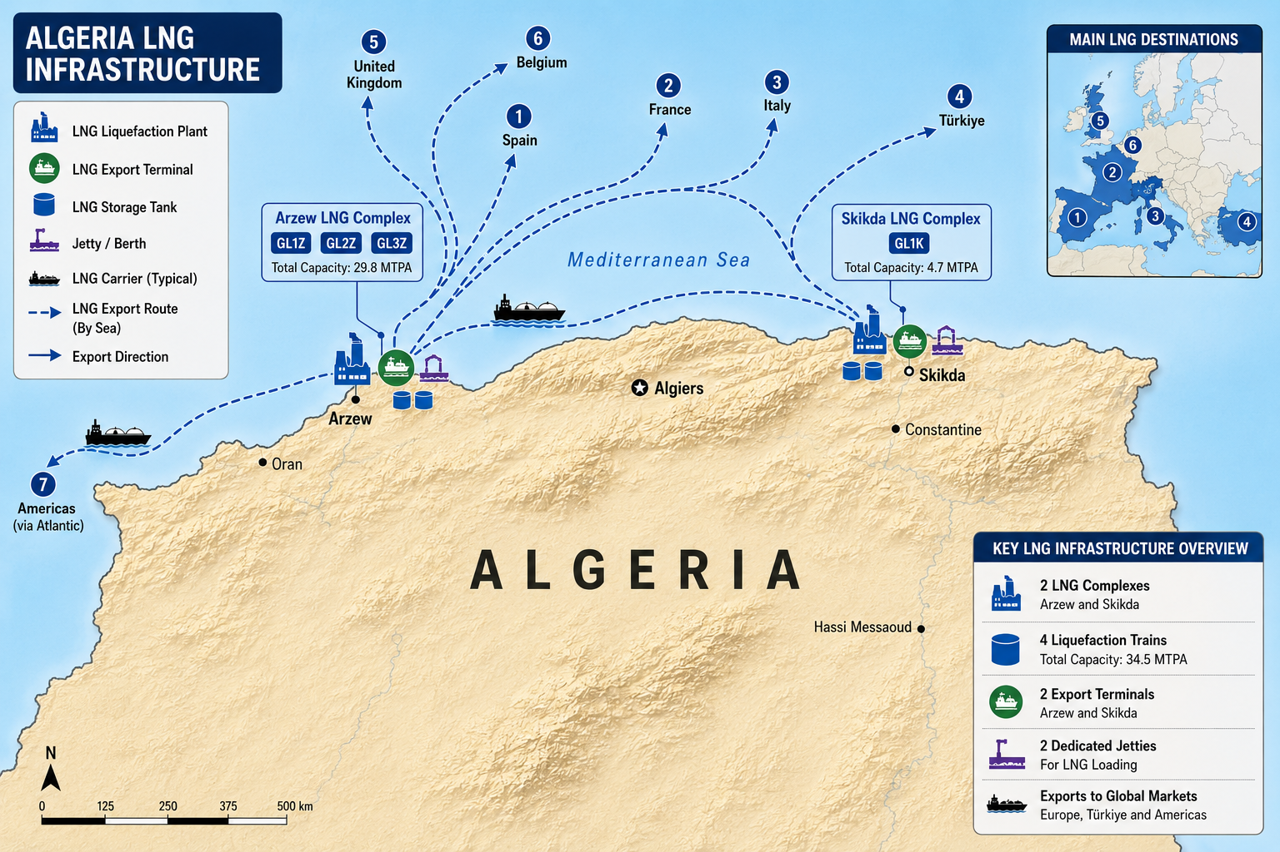
Figure 5 Map Showing Algeria LNG Infrastructure
Export Pipelines and LNG Facilities
Assets | Location | Nameplate Capacity | Status (2026)
TransMed (Enrico Mattei) | Hassi R'Mel – Tunisia – Sicily – Italy (+ Slovenia, Czechia) | ~ 30–33.5 bcm/yr | Operating well below capacity (≈21 bcm, 2024); substantial spare throughput
Medgaz | Hassi R'Mel – subsea – Almeria, Spain | ~ 10.5–10.7 bcm/yr | Near full capacity; expansion (+≈1 bcm) under discussion since early 2026
GME (Pedro Duran Farell) | Hassi R'Mel – Morocco – Spain/Portugal | ~ 12–13 bcm/yr | Shut since Oct. 2021 (Algeria–Morocco tensions); reopening unlikely near-term
Arzew/Bethioua LNG (GL1Z, GL2Z, GL3Z) | Oran region | ~ 20.8 mtpa nameplate | Operating; life-extension and reliability upgrades underway
Skikda LNG (GL1K) | Skikda | ~ 4.5 mtpa nameplate | New M3 jetty (2024); storage expansion with Sinopec
Trans-Saharan Gas Pipeline | Nigeria — Niger — Algeria | ~30 bcm/yr | Under implementation

Gas Monetisation Strategy through Pipeline Gas and LNG Exports
Algeria's gas monetisation strategy is based on maximising value from its natural gas resources through a combination of:
- Pipeline exports.
- LNG exports.
- Domestic industrial utilisation.
- Power generation.
- Petrochemical development.
This diversified approach reduces dependence on a single export mechanism and enhances resilience to changing market conditions.
Algeria's core monetisation model rests on a dual-channel export strategy: fixed, high-utilisation pipeline sales to adjacent Southern European markets (Italy via TransMed, Spain via Medgaz) underpinned by long-term contracts, complemented by more flexible LNG cargoes that can be redirected toward premium spot markets in Turkiye, North-West Europe and, opportunistically, Asia. This dual structure gives Sonatrach meaningful optionality (pipeline volumes provide contracted revenue stability, while LNG cargoes allow the company to capture premium pricing during periods of tight global supply, as occurred prominently in 2022–23).

Market Outlook
Wood Mackenzie forecasts Algerian marketed gas production to peak around 2027 before plateauing, as the current wave of south-western field developments matures and few untapped conventional prospects remain. The government's own 200 bcm/year target for 2030 is materially more ambitious than most independent forecasts and should be regarded as an aspirational target contingent upon successful shale gas commercialisation and sustained capital deployment rather than a base-case outcome. Under a central scenario, exportable surplus is likely to grow only modestly through the early 2030s as rising domestic consumption absorbs a meaningful share of incremental production, reinforcing the strategic importance of demand-side efficiency measures and, longer-term, renewable displacement of domestic gas burn.
On the demand side, European buyers are expected to maintain, and in some scenarios modestly increase, contracted offtake through the early 2030s as part of post-Russia supply diversification, even as EU decarbonisation policy caps the multi-decade growth trajectory. Italy's ENI and Spain's Naturgy are likely to remain Algeria's anchor long-term counterparties, while incremental volumes are increasingly directed toward Turkiye and, via LNG, toward premium Asian and other European spot markets.

Investment Opportunities
- Upstream frontier and shale exploration acreage offered under Algeria Bid Round 2026 and successor licensing rounds, particularly in the Ahnet, Berkine and Illizi basins.
- LNG train reliability, life-extension and boil-off-gas recovery works at Arzew and Skikda, where effective capacity currently trails nameplate capacity.
- Medgaz capacity expansion and associated compression investment on the Spain corridor.
- Enhanced oil and gas recovery services and equipment supply, given Sonatrach's emphasis on maximising recovery from mature fields such as Hassi R'Mel.
- Flare-gas recovery, methane-abatement and associated environmental-compliance investment tied to Sonatrach's 2024 climate strategy and EU methane-import requirements.
Risks
- Delayed south-west field development
- Algeria–Morocco diplomatic rupture
- EU long-run demand ceiling / decarbonisation
- Ageing LNG train reliability

Conclusion
Algeria's natural gas sector represents one of Africa's most mature and strategically significant examples of large-scale gas monetisation. Over several decades, the country has built an integrated value chain encompassing prolific gas fields, an extensive domestic transmission network, multiple export pipelines, world-class LNG infrastructure, and enduring commercial relationships with European markets.
As global energy systems evolve, Algeria's strategic priority for the coming decade is sustaining and enhancing its position as a regional gas hub by replacing reserves, modernising infrastructure, balancing domestic demand with export commitments, and aligning its gas industry with emerging low-carbon expectations.

