The Emergence of a South Atlantic Energy Investment Axis: New Capital Flows Between Africa and Latin America

Executive Summary
The traditional view of the Atlantic Ocean as a barrier between African and South American energy markets is rapidly evolving. African sovereign wealth funds and state-backed energy companies are increasingly positioned to pursue international investment opportunities in high-growth hydrocarbon basins, with Brazil's pre-salt sector and Argentina's Vaca Muerta representing logical future destinations given their capital intensity and technical complexity. This marks a significant evolution in South–South energy cooperation, driven by:
- Accumulated African deepwater experience (Nigeria, Angola, Congo, Mozambique)
- Capital recycling from mature offshore assets
- Demand for technically complex upstream development in Brazil and Argentina
- Strategic diversification away from traditional Western capital dependence

Strategic Investment Focus Areas
Target Region | Asset Class | Strategic Rationale
Brazil (Pre-Salt) | Deepwater Offshore | Access to high-productivity barrels; expertise in FPSO integration and subsea architecture.
Argentina (Vaca Muerta) | Shale / Tight Gas | Infrastructure buildout; gas-to-liquefaction (LNG) and pipeline monetization expertise.

Capital Flow Framework
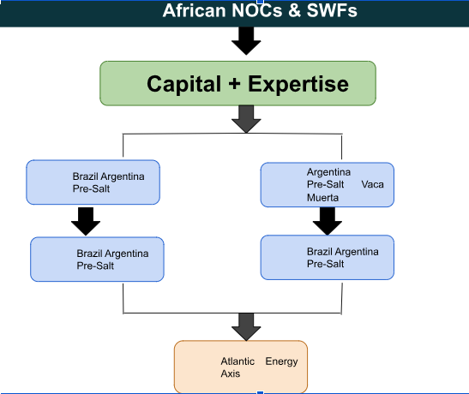

Basin Comparison
The table below summarizes how the core competencies built in African deepwater and FLNG projects map onto the two target basins.
Capability (African origin) | Brasil pre-salt relevance | Vaca Muerta relevance
Ultra-deepwater drilling & completions (Nigeria) | Direct overlap; pre-salt is among the most demanding deepwater environments globally | Limited — onshore shale, different technical discipline
FLNG design & operations (Mozambique, Congo) | High; both basins evaluating floating gas monetization for associated gas | Low; gas takeaway is primarily pipeline-based
HPHT reservoir engineering | High; pre-salt carbonate reservoirs are high-pressure, high-temperature | Moderate; some HPHT zones in deeper shale intervals
Local content & JV structuring under NOC frameworks | Moderate-high; Petrobras content rules mirrors NNPC-style mandates | High; provincial and federal content rules require similar navigation
Frontier fiscal regime negotiation | Moderate; Brazil's regime is comparatively mature and transparent | High; Argentina's incentive regime (RIGI) is still being tested by new entrants

Strategic Implications of the Emerging Atlantic Corridor Investment Axis
The emergence of the Atlantic Corridor signals a fundamental shift in how upstream investment, technology transfer, and energy diplomacy are structured across the Global South. The long-term implications extend beyond individual projects and could reshape the competitive dynamics of the global upstream industry.
- Implications for African National Oil Companies and Sovereign Wealth Funds
Historically, many African NOCs and state investment avenues primarily focused on domestic resource development, often relying on international oil companies (IOCs) for financing, technology, and project management. The Atlantic Corridor introduces a new phase in which African institutions become outward-looking investors.
This transition offers several strategic advantages which includes: Geographic diversification of hydrocarbon exposure, Reduced dependence on domestic fiscal and political environments, and Creation of international revenue streams denominated in hard currency. For example, participation in Brazilian pre-salt developments provides exposure to some of the world's lowest-cost and highest-productivity offshore reservoirs, potentially generating returns that can be reinvested into African upstream projects.
- Implications for Brazil's Pre-Salt Sector
The emergence of African capital and technical participation in Brazil's pre-salt sector could have profound implications for investment competition, project financing, operational efficiency, and geopolitical alignment. While Brazil remains one of the world's premier offshore investment destinations, the entry of African state-backed investors introduces a new strategic dimension to the sector's development trajectory.
Brazil's offshore acreage auctions are among the most competitive globally. The arrival of African investors could intensify bidding activity for: Exploration blocks, Farm-in opportunities, Producing assets, and Infrastructure investments

Strategic Implications for Argentina's Vaca Muerta Development

The emergence of the Atlantic Corridor investment framework has particularly significant implications for Argentina's Vaca Muerta formation, one of the world's largest unconventional hydrocarbon resources. While much attention has focused on African participation in Brazil's deepwater sector, the strategic opportunities in Argentina may be even more transformative because Vaca Muerta faces a critical challenge: converting vast shale resources into commercially viable export revenues.
The involvement of African sovereign wealth funds, national oil companies, and LNG-focused operators introduces a new source of capital, technical expertise, and market connectivity that could accelerate Argentina's ambition of becoming a major global oil and gas exporter. Unlike Brazil's pre-salt sector, which is primarily an offshore oil story, Vaca Muerta represents a broader value-chain opportunity encompassing upstream shale development, midstream infrastructure, LNG exports, and industrial gas monetization.

Acceleration of FPSO Demand and Offshore Infrastructure Growth
Brazil's development model is heavily dependent on Floating Production Storage and Offloading units (FPSOs). The participation of African operators familiar with FPSO-based developments can stimulate:
- New FPSO orders
- Shared procurement strategies
- Joint vessel ownership structures
- Regional offshore service networks
Risk
Risk category | Description
Political alignment risk | Cross-continental state capital exposure
Currency volatility | Multi-currency financing exposure (BRL, NGN, USD)
Regulatory divergence | Brazil/Argentina fiscal regime variability
Technical execution risk | Deepwater + shale integration complexity
Capital repatriation constraints | SWF liquidity lock-in cycles

Outlook
The Atlantic Corridor is expected to evolve into a formalized upstream investment axis, characterized by:
- Structured African participation in Brazilian offshore licensing rounds
- Equity stakes in Argentine shale-to-LNG export infrastructure
- Expansion of African service companies into Latin American drilling and subsea markets
- Creation of blended South–South upstream financing platforms

Conclusion
The emergence of the Atlantic Corridor signals a rebalancing of global upstream capital architecture. African energy actors are no longer peripheral participants but are becoming strategic allocators of global upstream capital, leveraging deepwater expertise to gain exposure to some of the world’s most productive and technically advanced hydrocarbon basins.

