FROM MATURE PRODUCER TO EMERGING FRONTIER
COMPARING NIGERIA'S OML 118 (BONGA) AND NAMIBIA'S ORANGE BASIN DEVELOPMENTS

Nigeria’s OML 118 illustrates what a successful deep-water hub looks like after decades of de-risking: Bonga has been onstream since 2005, reached its one-billionth barrel in 2023, and is still being extended through the Bonga North tie-back sanctioned in 2024. The asset benefits from established FPSO infrastructure, reservoir surveillance, a local contractor ecosystem, and a regulatory architecture that while still complex—is familiar to global upstream investors.
Namibia’s Orange Basin represents the opposite end of the lifecycle. Venus and Mopane have proven a working hydrocarbon system, high-quality reservoirs, and globally material scale, but commercialization remains a front-end challenge rather than an operating reality. The basin still has to convert discoveries into development concepts, service corridors, and long-term fiscal confidence.
- For investors, Bonga is lower-risk, brownfield, and cash-flow anchored; Orange Basin positions are higher-risk but higher-optionality.
- For EPC/subsea suppliers, Bonga rewards repeatability and tie-back efficiency; Namibia rewards first-mover capability in integrated hub design.
- For governments, the comparison highlights the difference between monetizing proven barrels and institution-building around pre-first-oil discoveries.
- For portfolio strategy, the central trade-off is mature execution certainty versus frontier resource upside.

Comparative overview
Dimension | Nigeria OML 118 / Bonga | Namibia Orange Basin
Lifecycle position | Operating deep-water hub with brownfield expansion | Pre-first-oil frontier undergoing appraisal and concept selection
Core reference assets | Bonga Main, Bonga North, earlier Bonga NW tie-back | Venus, Mopane, wider PEL 39 / Orange Basin learnings
Water depth | >1,000 m at Bonga | Approx. 1,200–1,900 m at Mopane; up to 3,000 m at Venus block
Distance offshore | About 120 km | About 200 km (Mopane) to 290 km (Venus)
Host infrastructure | Existing Bonga FPSO enables tie-backs | No producing host yet; first hub(s) still being designed
Commercial status | Producing + sanctioned tie-back | Discoveries proven, commercialization still advancing
Fiscal posture | PIA deep-water royalties + CIT; HCT not applied to deep offshore | 5% royalty, 35% PIT, APT structure, state participation
Local content setting | Mature and more prescriptive | Emerging and policy-building stage
Table 1. High-level comparison of the two development theatres.

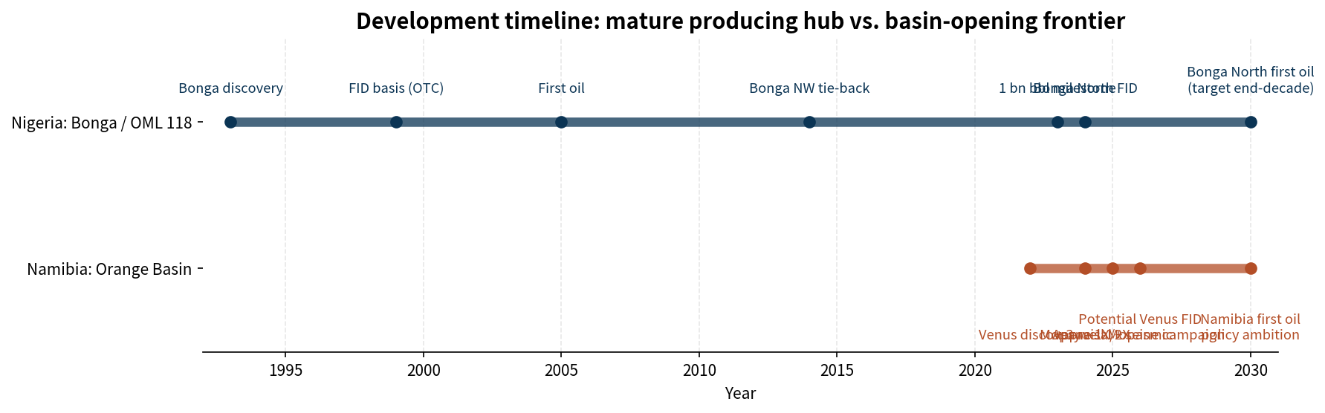
Figure 1. Development timeline compiled from Shell, OTC/OnePetro, TotalEnergies, Galp, NAMCOR, and Reuters reporting.

3. Nigeria briefing: OML 118 (Bonga)

3.1 Asset position and development history
Bonga is the benchmark case for Nigerian deep-water scale-up. The field lies in OML 118 around 120 km offshore in water depths exceeding 1,000 m. According to Shell and OTC/OnePetro, Bonga was discovered in 1993, moved toward development at the end of the 1990s, started production in 2005, and delivered its one-billionth barrel in 2023. It remains one of the clearest examples of a long-life FPSO-centered hub in West Africa.
The field’s performance record is unusually strong. OTC/OnePetro reports cumulative output of more than 1.0 billion barrels of oil, 815 Bscf of gas exports, and 1.5 billion barrels of injected water through 39 oil producers and 36 water injectors over 18 years. That history matters strategically: Nigeria’s Bonga story is no longer about discovery risk, but about host optimization, reservoir management, and incremental recovery capture.
Metric | Value | Implication
Production start | 2005 | Long operating history and real reservoir-performance evidence
Bonga FPSO capacity | 225 kbpd | Large installed liquids-processing base for tie-back strategy
Cumulative production milestone | 1 billion barrels in 2023 | Confirms long-term reservoir and facility resilience
Bonga North recoverable resource | >300 MMboe | Material brownfield growth inventory
Bonga North peak production | 110 kbpd | Meaningful production sustainment into next decade
Bonga North well scope | 16 wells (8 producers + 8 injectors) | Subsea-intensive but still host-led, not new-hub-led
Table 2. Key technical facts for Bonga Main and Bonga North.

3.2 Why Bonga is a mature-producer template
The core technical advantage at Bonga is infrastructure leverage. Shell’s 2024 FID note states that Bonga North is a subsea tie-back to the existing Bonga FPSO, requiring 16 wells, FPSO modifications, and new subsea hardware. TechnipFMC’s disclosed contract scope—trees, manifolds, jumpers, controls, and services—reinforces the point: this is a replication-and-integration project, not a first-of-its-kind national buildout.
That distinction reduces cycle risk. Mature-hub developments can draw on known fluid behavior, proven export routes, and previously localized vendor capability. In practical terms, OML 118’s next value tranche depends less on whether hydrocarbons exist and more on whether tie-back economics, uptime, drilling execution, and fiscal predictability remain attractive enough to sustain capital discipline.
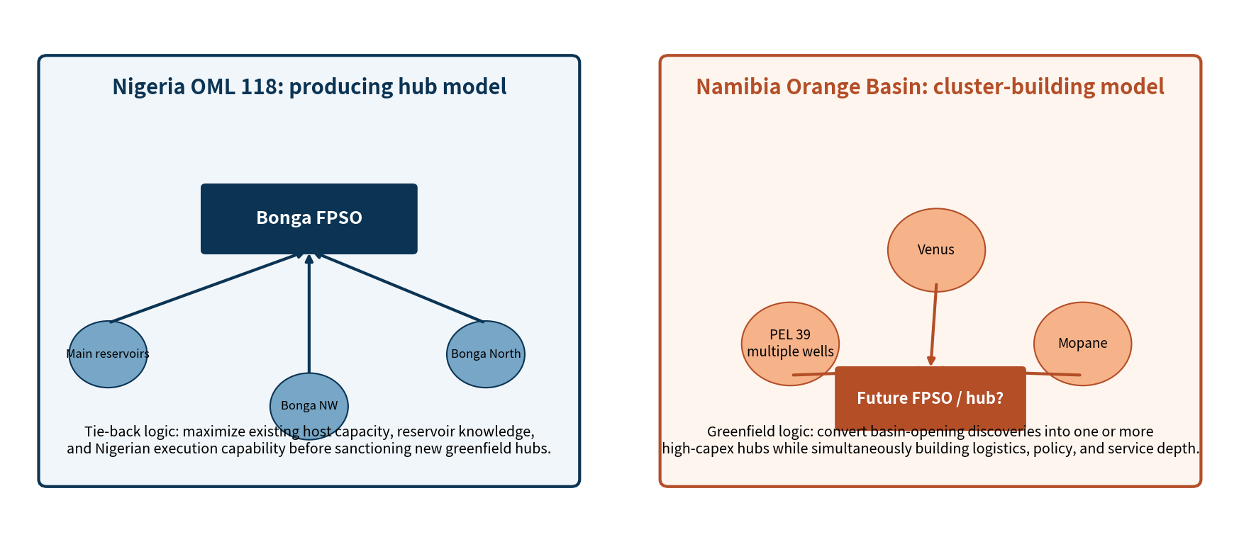
Figure 2. Original schematic: producing hub model in OML 118 versus cluster-building logic in Namibia. Compiled from public disclosures.

3.3 Fiscal and local-content environment
Nigeria’s Petroleum Industry Act materially reshaped the deep-water fiscal architecture. Morgan Lewis summarizes that deep offshore projects are subject to a 7.5% oil royalty, with a lower 5% rate for deep offshore fields producing no more than 50,000 bpd, plus an oil-price royalty from 0% to 10%. Crucially, hydrocarbon tax does not apply to deep offshore profits, but companies remain subject to 30% companies income tax and tertiary education tax. For investors, that produces a clearer deep-water fiscal logic than older petroleum profits tax structures, even though above-ground and policy risks remain non-trivial.
Nigeria’s local-content regime is much more developed than Namibia’s. KPMG’s overview of the Nigerian Oil and Gas Industry Content Development Act highlights mandatory Nigerian content plans, first consideration for Nigerian goods and services, a 1% contribution to the Nigerian Content Development Fund, domestic fabrication and welding requirements, and tighter expectations around local employment and technology transfer. This can increase contracting complexity and cost, but it also means Nigeria already possesses a deeper domestic supply-chain base than a first-oil frontier.

3.4 Current ownership and capital posture
As of Shell’s May 2025 announcement, the producing OML 118 PSC was held by SNEPCo 55%, Esso 20%, Nigerian Agip Exploration 12.5%, and TotalEnergies 12.5%, on behalf of NNPC. Shell disclosed that, upon completion of its acquisition of TotalEnergies’ stake, SNEPCo would rise to 67.5%. The signal is strategic: major capital is still willing to consolidate around Nigeria’s proven deep-water core even as the onshore and shallow-water narrative becomes more mixed.

4. Namibia briefing: Orange Basin developments

4.1 Venus, Mopane, and the frontier-development proposition
Namibia’s Orange Basin is one of the most important frontier basins in the current global upstream cycle because it has crossed the most critical exploration threshold: it has proven a working petroleum system with multiple large discoveries. TotalEnergies’ 2022 Venus-1X announcement reported approximately 84 m of net oil pay in a good-quality Lower Cretaceous reservoir in deep offshore Block 2913B. Impact Oil & Gas further describes Venus as approximately 290 km offshore, drilled to 6,296 m total depth, with light sweet oil and associated gas in an Albian basin-floor fan play.
Mopane expanded the basin’s strategic relevance. Galp reported in April 2024 that the Mopane complex contained hydrocarbon in-place estimates of 10 billion boe or higher before additional exploration and appraisal wells, with flow rates during well testing reaching the maximum allowed limit of 14 kboepd. Galp also described low oil viscosity, minimal CO2, no H2S, and high-quality reservoir properties—exactly the kind of fluid and rock indicators that keep a frontier basin in global capital-market focus.
Asset / area | Publicly disclosed facts | Strategic reading
Venus (PEL 56 / Block 2913B) | 84 m net oil pay; ~290 km offshore; block in water depths up to 3,000 m; development studies advancing | Most advanced Namibian oil development candidate and likely anchor project
Mopane (PEL 83) | Light oil and condensate; 10+ bn boe in-place estimate; 2024–2025 appraisal and 3D seismic; 2026 three-well campaign planned | Potential multi-hub growth engine, but still appraisal-led
PEL 39 / Shell area | Multiple wells drilled, several discoveries, but commercial hurdles remain | Important reminder that geological success does not automatically equal commercial sanction
Table 3. Orange Basin asset snapshots.

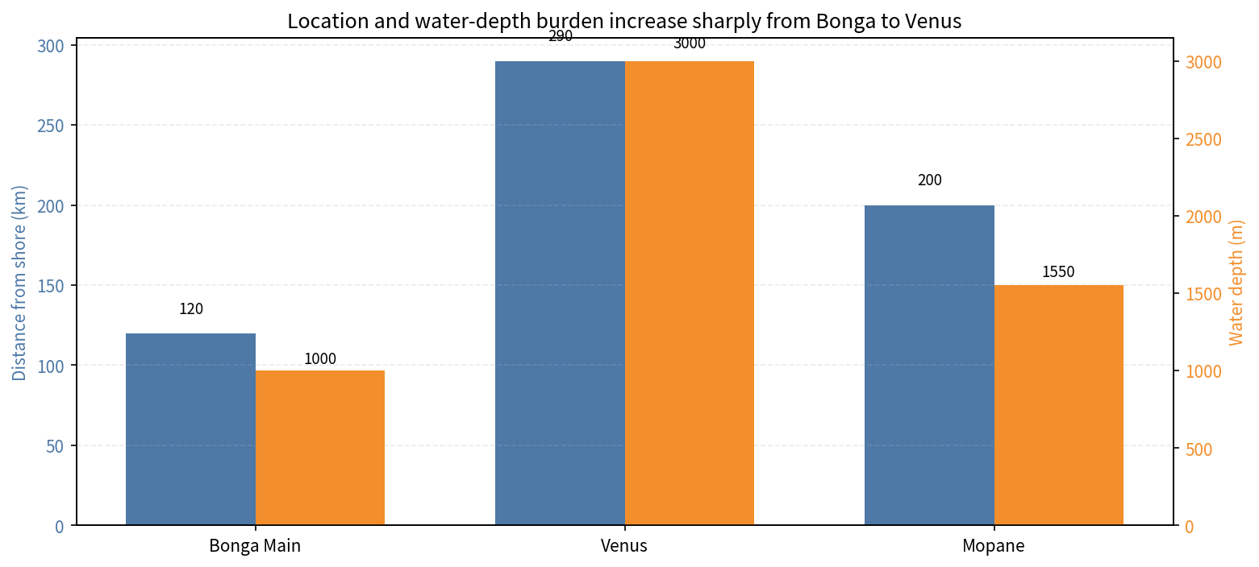
Figure 3. Distance from shore and water-depth burden derived from Shell, TotalEnergies, Impact, and Galp disclosures.

4.2 Why Namibia is not yet “the next Bonga”
The Orange Basin may eventually support a development wave comparable in strategic significance to Nigeria’s deep-water rise, but it is not yet at that stage. The physical context is harsher: Venus sits farther offshore and in deeper water than Bonga, while the country has no producing offshore host, no comparable deep domestic vendor base, and no embedded cycle of brownfield tie-backs. Every major component—ports, logistics, fabrication pathways, marine support, first-wave regulatory execution, and eventual decommissioning architecture—must be assembled in parallel with project sanctioning.
Recent market signals confirm both promise and caution. TotalEnergies and Galp stated in January 2026 that Venus has a well-defined development concept and could reach FID in 2026, while Mopane is due for a three-well exploration/appraisal campaign in 2026. At the same time, Reuters reported in January 2025 that Shell wrote down around $400 million on discoveries in PEL 39 after concluding they could not then be confirmed for commercial development because of technical and geological difficulties, including permeability and gas-content issues. The basin therefore remains highly prospective—but still selective.

4.3 Fiscal, state participation, and local-content trajectory
Namibia’s fiscal regime is relatively straightforward by African upstream standards. NAMCOR’s fiscal summary sets out a 5% royalty on gross revenue, 35% petroleum income tax, and a three-tier additional profits tax structure that only bites after specified real rates of return. The cited SEC petroleum agreement example also shows how second- and third-tier APT rates can be set contractually at 7.5% and 10%, while NAMCOR commonly carries a 10% interest in licenses. The regime is investment-oriented, but investors will watch closely for how stability, state participation, and any future policy revisions interact once first oil approaches.
On local content, Namibia is still writing the playbook. The 2025 draft National Upstream Petroleum Local Content Policy prioritizes regulatory clarity, supplier development, skills transfer, procurement localization, R&D, and meaningful Namibian participation in financing and services. Relative to Nigeria, the regime is less institutionalized and less demanding today, but that flexibility exists precisely because the domestic offshore ecosystem is still being built. The burden for operators is therefore less about legacy compliance and more about helping create the market itself.

4.4 Current operator configuration and near-term outlook
NAMCOR’s January 2025 operational update recorded pre-transition interests of 50.5% TotalEnergies / 30% QatarEnergy / 9.5% Impact / 10% NAMCOR in PEL 56, and 80% Galp / 10% NAMCOR / 10% Custos in PEL 83. By January 2026, TotalEnergies and Galp had announced a broader partnership in which TotalEnergies would become operator of PEL 83 while Galp would enter Venus-hosting PEL 56 and PEL 91. That emerging cross-asset alignment is strategically important because it raises the odds of coordinated hub-building rather than isolated project design.

5. Side-by-side strategic comparison
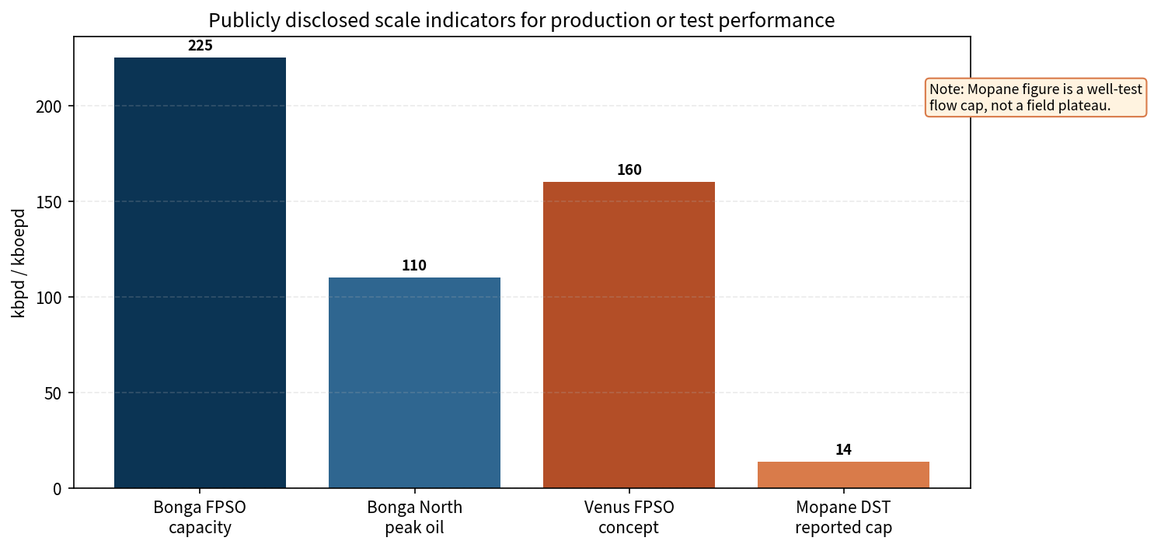
Figure 4. Publicly disclosed scale indicators for facilities or well-test performance.
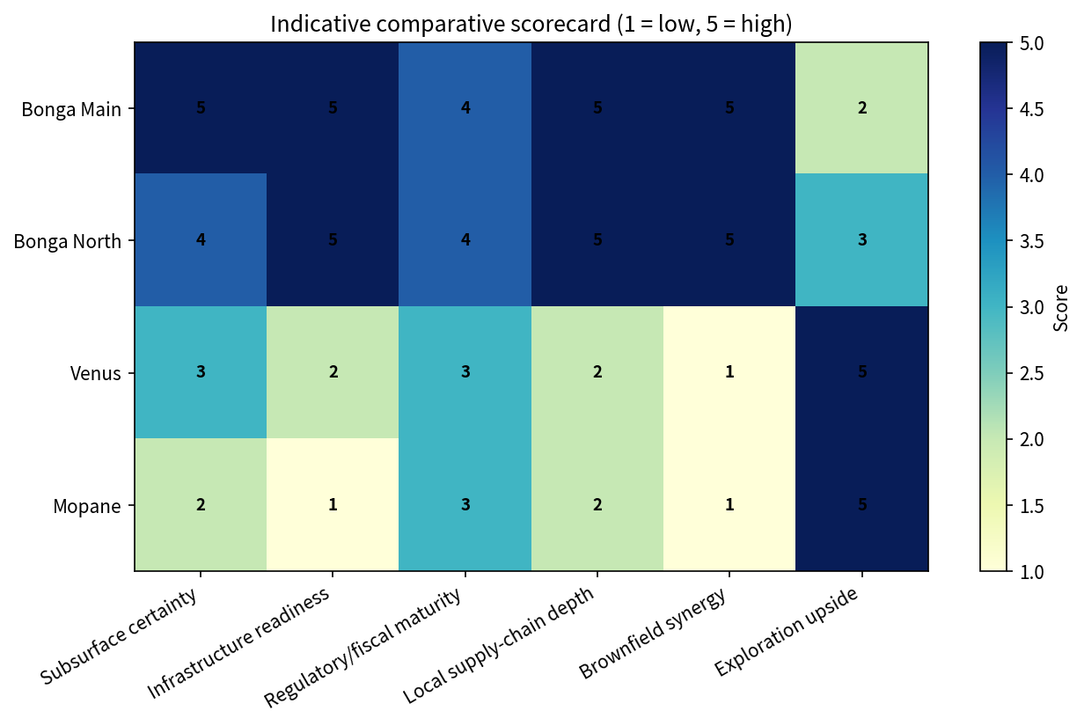
Figure 5. Indicative comparative scorecard compiled from public evidence in cited sources; scores are analytical judgments, not operator disclosures.
Theme | Nigeria / Bonga take | Namibia / Orange Basin take
Geology risk | Mostly shifted from discovery to recovery optimization | Still includes appraisal, fluid, and commerciality discrimination risk
Facilities strategy | Exploit existing FPSO and subsea architecture | Select and anchor first host(s); likely multiple hub candidates over time
Capital efficiency | Higher via brownfield tie-back leverage | Lower at outset due to greenfield system build
Policy challenge | Execution under a more mature but denser regulatory regime | Preserve investor confidence while growing local participation expectations
Supply chain | Deeper domestic capability and localization history | Faster room for international first movers but less local depth today
Portfolio role | Production resilience / near- to medium-term cash flow | Long-dated growth optionality and basin-entry value
Table 4. Strategic comparison matrix.

6. What this means for stakeholders

6.1 For E&P companies
- Nigeria rewards portfolio players that can monetize near-field growth around existing hosts and tolerate a denser policy/compliance environment.
- Namibia rewards frontier positioning, basin-shaping capability, and patience through a longer pre-cash-flow development arc.

6.2 For lenders and investors
- Bonga-type assets fit lower-risk reserve-based and cash-flow-backed narratives better than Orange Basin pre-FID positions.
- Orange Basin exposure offers more upside asymmetry, but underwriting must emphasize concept selectivity, gas handling, and supply-chain execution risk.

6.3 For service companies
- Nigeria favors repeat subsea, brownfield modification, surveillance, and intervention capability.
- Namibia favors first-wave deepwater logistics, integrated project definition, marine support, and local capability partnerships.

6.4 For policymakers
- Nigeria’s challenge is reducing friction without losing local-value capture.
- Namibia’s challenge is sequencing local-content ambition so it catalyzes—not delays—first-wave commercial developments.

7. Bottom line
OML 118 demonstrates how a deep-water province compounds value once infrastructure, institutions, and reservoir knowledge are in place. Namibia’s Orange Basin demonstrates how quickly frontier acreage can become globally strategic once multiple discoveries prove scale. The key difference is timing: Bonga monetizes known capability today, whereas Namibia is still building the architecture that could monetize its discoveries tomorrow. In short, Nigeria offers a mature producer’s execution template; Namibia offers an emerging frontier’s growth optionality.

